**Bregghan Point of Sale System**

Project Documentation Submitted to the Faculty of the

School of Computing and Information Technologies

Asia Pacific College, Magallanes Makati City

In Partial Fulfillment for the subject:

Applied Project for IT-MI (MCSPROJ)

By:

Ramon Benedict V. Elloso

Carlos C. Ligligen

Andrei Gabriel B. Palma

Donne Paolo Y. Tarinay

Dr. Manuel L. Calimlim Jr.

Adviser

ASIA PACIFIC COLLEGE

Approval Sheet

Bregghan Sales and Stock Tracer Responsive Webapp

Prepared and submitted by

Ramon Benedict V. Elloso

Carlos C. Ligligen

Andrei Gabriel B. Palma

Donne Paolo Y. Tarinay

In Partial Fulfillment of the Requirements for the Degree of

Bachelor of Science in Information Technology

Examined and Recommended for Acceptance and Approval for

Capstone Presentation

___________________________

Dr. Manuel L. Calimlim, Jr. , Adviser

Panelists

___________________________

<Name>, Chairperson

|  |  |
| --- | --- |
| ___________________________ | ___________________________ |
| Ms. Roselle Wednesday L. Gardon | Ms. Jo Anne M.de la Cuesta |

Acceptance and Approved in Partial Fulfillment of the Requirements for the Degree of

Bachelor of Science in Information Technology

___________________________

Rhea-Luz R. Valbuena

Executive Director

School of Computing and Information Technologies

Table of Contents

List of Figures v

List of Tables vii

I. Introduction 8

1.1 Project Context 8

1.2 Statement of the Problem 8

1.3 Objectives 9

1.4 Significance of the Project 9

1.5 Scope and Limitations 10

II. Review of Related Literature / Systems 10

2.1 Related System 12

2.2 Synthesis 14

III. Technical Background 16

3.1 Current System 16

3.1.1 List of Processes 16

3.1.2 SWOT Analysis 18

3.2 Proposed System 19

3.2.1 Software 20

3.2.2 Hardware 21

3.2.3 Network 22

IV. Methodology 22

4.1 Requirements Analysis 23

4.1.1 Product Backlog / User Stories 23

4.1.2 Event Tables 27

4.1.3 Use Case Diagrams 29

4.1.4 Use Case Full Description 31

4.1.5 Gap Analysis 36

4.2 System Analysis and Design 37

4.2.1 Context Diagram 37

4.2.2 Data Flow Diagrams 38

4.2.3 Entity-Relationship Diagrams 42

4.2.4 Activity Diagrams 43

4.2.5 Object Diagram 50

4.2.6 Class Diagrams 50

4.2.7 Sequence Diagrams 51

4.2.8 State Machine Diagram 58

4.2.9 Package Diagram 59

4.3.10 Component Diagram 60

4.3.11 Deployment Diagram 61

4.3.12 Data Dictionaries 62

V. Results and Discussion 68

5.1 Release Plan 68

5.2 Prototype 69

5.3 Use Classes and Characteristics 74

VI. Conclusion 74

References 75

Appendices 76

Appendix A: Project Vision 76

Appendix C: Product Roadmap 77

Appendix E: Team Meetings 79

# List of Figures

Figure 1 eHopper 13

Figure 2 Peddlr 13

Figure 3 POS by Shopify 14

Figure 4 Proposed System 19

Figure 5 Use Case Diagram 30

Figure 6 Context Diagram 37

Figure 7 Data Flow Diagram Level O 38

Figure 8 DFD Level 1 Manage Inventory 39

Figure 9 Add Item 40

Figure 10 View Inventory 41

Figure 11 Entity Relationship Diagram 42

Figure 12 Scan Item / Remove Item / Payment / Receipt 43

Figure 13 View Inventory 44

Figure 14 Add Item 45

Figure 15 Edit Items 46

Figure 16 Delete Item 47

Figure 17 Sales Report Page 48

Figure 18 Analytics Report Page 49

Figure 19 Object Diagram 50

Figure 20 Class Diagram 51

Figure 21 Sales / Analytics Report 52

Figure 22 Delete Item 53

Figure 23 Edit Item 54

Figure 24 Add Item 55

Figure 25 View Inventory 56

Figure 26 Scan Item / Remove Item / Payment / Receipt 57

Figure 27 State Machine Diagram: Number of items in Inventory 58

Figure 28 Package Diagram 59

Figure 29 Component Diagram 60

Figure 30 Deployment Diagram 61

Figure 31 Login Screen 69

Figure 32 Home Screen 70

Figure 33 Inventory Screen 71

Figure 34 Add Item Screen 71

Figure 35 Edit Item Screen 72

Figure 36 Sales Screen 72

Figure 37 Analytics Report 73

Figure 38 Meeting for Revisions from Client 79

Figure 39 Meet for Event Table and Paper Revisions 79

Figure 40 Meet for CFD and DFD diagram 80

Figure 41 Meeting for updates of Diagrams 80

Figure 43 Meeting with adviser 81

# List of Tables

Table I List of Processes 15

Table II SWOT Analysis 17

Table III Software Requirements 20

Table IV Hardware Specifications Tablet 20

Table V Hardware Specifications Computer 21

Table VI Hardware Printer 21

Table VII Scanner 22

Table VIII Event Table 27

Table IX Use Case Full Description 1 30

Table X Use Case Full Description 2 30

Table XI Use Case Full Description 3 31

Table XII Use Case Full Description 4 31

Table XIII Use Case Full Description 5 31

Table XIV Use Case Full Description 6 33

Table XV Use Case Full Description 7 33

Table XVI Use Case Full Description 8 34

Table XVII Use Case Full Description 9 34

Table XVIII Use Case Full Description 10 35

Table XIX Use Case Full Description 11 35

Table XX Use Case Full Description 12 36

Table XXI Gap Analysis 36

Table XXII Data Dictionary: admin login 63

Table XXIII Data Dictionary: cashier login 63

Table XXIV Data Dictionary: admin 63

Table XXV Data Dictionary: sales report 64

Table XXVI Data dictionary: analytics report 64

Table XXVII Data dictionary: Orders 65

Table XXVIII Data dictionary: Payment 65

Table XXIX Data dictionary: Receipt 66

Table XXX Data dictionary: cashier 66

Table XXXI Data dictionary: inventory 67

Table XXXII Data dictionary: items 67

Table XXXIII Data dictionary: products 67

Table XXXIV Data dictionary: add/edit items 68

Table XXXV User Classes and Characteristics 75

Table XXXVI Product Roadmap 79

# Introduction

## Project Context

Bregghan mini grocery store is a family-owned business which is being managed by Ms. Devilyn Ligligen. It is located at Mt. Makiling Street. Makati City. On a regular basis, the grocery store is managed by 2 staff personnel, and both are selling the products to customers. The grocery store supplies retail/wholesale/bulk to residents and “sari-sari” stores in the area. The store only accommodates 1-5 persons walk-in. In addition, the store offers different varieties of products ranging from Dairy, Beverages, Liquor, Frozen foods, Canned goods, etc.

On a daily basis, the mini grocery store currently uses a pen and paper to track the stocks and sales that are going in and out of the store. In addition, the store’s current Point Of Sales System is the manual computation and the receipts which are hand written. Furthermore, the mini grocery store’s fast and slow moving products are not being observed properly and they only replenish the stocks when they see that an item is already out of stock. Moreover, the store only relies on the records of receipts in tracking their inventory and sales which is tedious for the staff since they need to take care of the receipts in order to know the stocks that are left and they only rely with the information that are in those receipts. With these pain points in their current system, the group aims to improve it with the integration of a stock and sales responsive webapp that can improve the store’s inventory management and point of sales.

## Statement of the Problem

The Client is having difficulty in tracking the records sold all year-long (within the day, week, month, and year), due to it being manually recorded through a receipt book.

Specific Problems

* Items on stock are not properly monitored, thus the Client may not be able to replenish their inventory on time.
* The client experiences a miscalculation of total sold items due to human error on their current process.
* The client may lose potential customers due to the lack of items on stock.

## Objectives

General Objectives

* To develop a responsive webapp that tracks sales and stocks for Bregghan mini grocery store.
* Decreases the number of steps that the user can do in the whole transaction for faster checkouts.

The group plans to further address the general objective of the project to:

Inventory:

* Digitize 100% the recording of stocks and sales.
* Notifies the user that the stocks are at a critical level.

Sales:

●     Computation of items that are sold are automated.

Reports:

●     Produce a report that will show the records sold daily, weekly, monthly, and yearly

## Significance of the Project

This project will aid the staff and manager of Bregghan mini grocery store in terms of providing a better way of monitoring the stocks and sales in real time and in a digitized way because human errors and the workload that they gain within the day can be lessened by the application. Moreover, the system will aid the users in terms of listing the stocks that are left and the items that are sold.

Specifically, the beneficiaries of this capstone paper are:

Mini Grocery Owners- The owner will most benefit from this project. They will have easier workloads because of the project as it would help in monitoring the sales and stocks of bregghan mini grocery store.

Staff - The staff of Bregghan store will benefit directly from this project because they will be the ones using the application once it is deployed. The project will reduce the workload of the staff since they can monitor the stocks and the items that go in and out of the store in real time. Moreover, it will benefit the user to monitor the stocks and sales with ease and it will upgrade the current system of the store which has just one basis for all the items that are sold.

Small business owners - future small business owners will benefit from this project due to the POS like system that is within the application. In addition, they can monitor stocks and supplies that are going in and out of the store and in terms of computation of the total prices, it can print a receipt which has a history in the system.

To Future Developers - Future developers will benefit from this project because it can act as a reference to any similar or related project.

Customers- Customers will also benefit from this project because they will have a better copy of their receipts.

## Scope and Limitations

The project’s scope is limited to the requirements which are provided by the client which is the sales and stock tracer and a system wherein the user can have a copy of the items that are sold in an efficient way, and both need to be in an application. The project focuses on addressing the pain points of the Bregghan mini grocery store which is the lack of monitoring in sales, stocks, and they are limited to pen and paper only. In addition, the store only uses the receipts as a basis to track the stocks and the items that are sold.

Regarding the limitations of the project, it is only limited to the following:

1. The time allowed to work on the project, which is three terms.

2. The staff of Bregghan mini grocery store.

3. PWD and Senior citizen discounts are not part of the system.

# Review of Related Literature / Systems

Point of Sale (POS) System

A point of sale (POS) is a system that businesses use to manage sales transactions. A point-of-sale system facilitates the completion of a business transaction between a client and a corporation. A point-of-sale (POS) system is a computerized network that consists of a primary computer connected to many checkout terminals and backed by various hardware components ranging from barcode scanners to card payment terminals (Erply, 2015).

Features of the Point of Sales System

1. Better Inventory Management

A point-of-sale system makes inventory management simple. It allows you to keep track of your inventory in real time and see how many products you own over time (Alicepos, 2020).

1. Increased Efficiency

The efficiency of your store will tend to improve when compared to a store without a POS system. It can assist businesses in becoming more efficient and productive. Furthermore, Brophy (2021) shows about half of shoppers prefer to purchase in person, with long checkout queues being the most common complaint. Point-of-sale features are useful in this situation. POS solutions simplify and speed up checkout while also improving every step of the consumer journey, from research to post-purchase (Alicepos, 2020).

1. Analytics Reports

Reports for several parts of the business are automatically generated with a POS system. This includes sales, contacts, prices, purchases, inventory, and so on. In addition, Fuscaldo (2021) stated that POS reports may assist you in deciding what products to order, what promotions to run, and where you should focus your future growth efforts (business news daily, 2017).

1. Employee Management

Most POS systems have employee management features such as tracking employee sales, and performance. This makes it simple to evaluate who your top earners are and who can benefit from more training. These technologies can be used to run competitions and reward top performance. (Peek, 2021)

1. Sales Tracker

A thorough report on sales results must be generated by the point of sale system. It should be able to report takings and outgoings on an hourly, daily, weekly, monthly, and yearly basis so that business owners can quickly comprehend their overall success. (Jain, 2019)

1. Loyalty awards

Customer loyalty refers to a person's readiness to buy from or cooperate with a firm repeatedly. It is a driving force that encourages consumers to stick with a brand by giving them something more in addition to the product or service they bought.

In fact, research shows that repeat customers spend 67 percent more on average than new customers, implying that loyal customers make up most of your revenues. (Ahmad, 2022)

Advantages and Disadvantages of the POS System

According to Polanz in 2011 [1], the flexibility and automation that a new point of sale system provides over manual processes is a key motivator for upgrading systems. A POS system is a means to collect and aggregate sales data automatically, which can then be used to produce a variety of sales reports including: daily reports with historical data, six week history reports, top selling categories, top margin categories, top margin customers, top margin items, customer rank by sales, top selling items, and sales by time of day (Logicerp, 2022).  
  
As discussed in Erply in 2015, a POS system streamlines the management of your company's paperwork. Bills and orders, sales numbers, and reports are all easily managed. POS systems, in addition to improving the productivity of the office environment, also improve the efficiency of the everyday sales environment through POS features such as barcode scanners (Erply, 2015).  
  
However from Kimmons in 2017, The entire aim of a point of sale system is to connect a single register to a wider network of data that would otherwise be unavailable or inconvenient to access. As a result, many businesses prefer a web-based system to a software-based system since it optimizes this part of the point-of-sale system. This added benefit, however, comes at a cost, as you will be required to pay for Internet access on your register as well as a monthly charge to the provider.

## Related System

eHopper

The eHopper, POS system provides all the functionality you will need to run a successful grocery store. Improve inventory management of huge grocery supply so you never run out, accept several payment kinds, including EBT, and sell your things in different units of measurement by speeding up checkouts for faster queues (ehopper, n.d.).



Figure 1 eHopper

Peddlr

Peddlr is a mobile Point of Sale (POS) application that assists micro and small enterprises, among other things. The said application allows you to automatically track sales and costs, as well as generate basic accounting reports to help you better understand your company's success (peddlr, 2021).

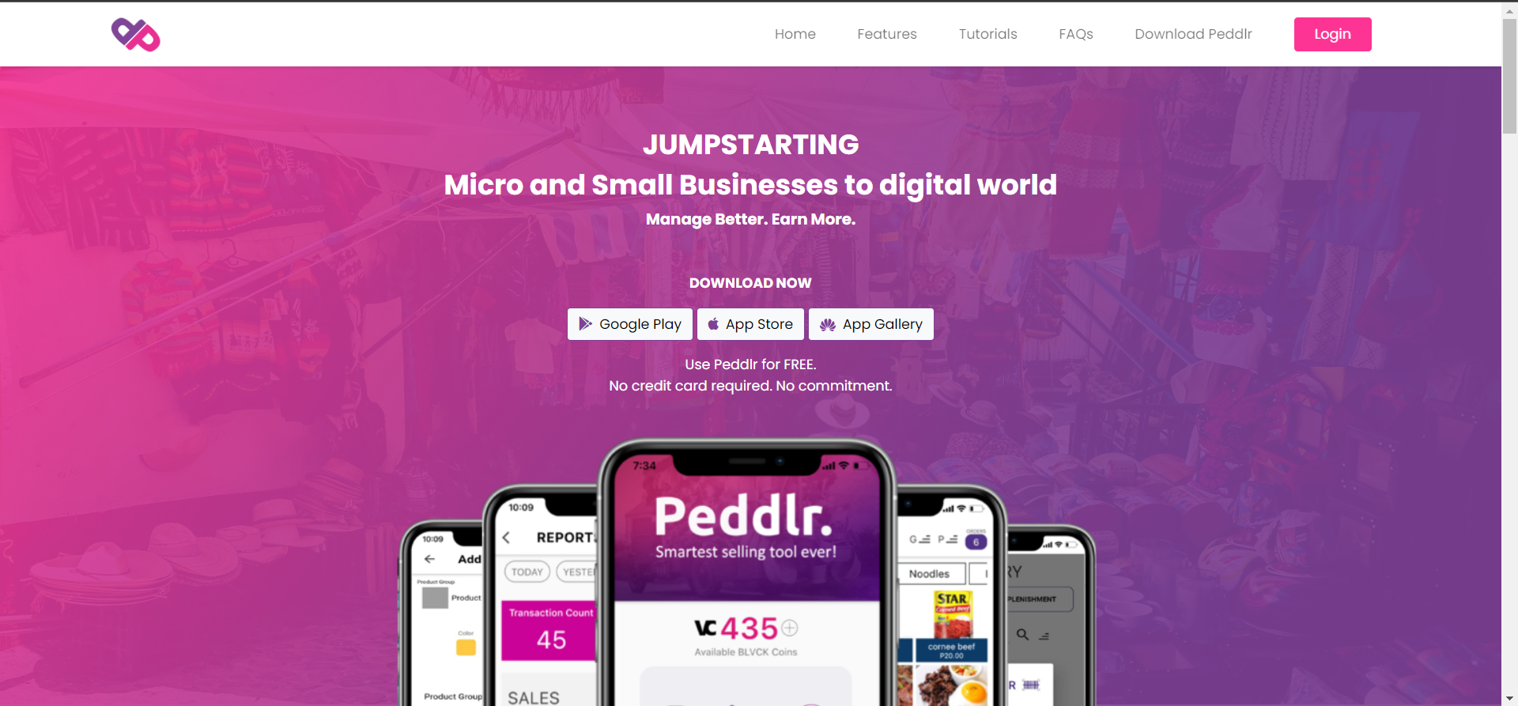

Figure 2 Peddlr

POS by Shopify

Shopify is an e-commerce website platform for building and managing online shops. They launched their Shopify POS project in 2013, which allows you to customize your POS systems to fit your business. It includes features such as inventory management, staff management, checkouts, reports, and payments (shopify, 2020).



Figure 3 POS by Shopify

## 2.2 Synthesis

The researches and systems discussed in this chapter show the significance of the developers' desired outcomes. The current system of Bregghan Store faces inefficient tracking of sales and stocks, which leads to loss of sales and inaccurate records of inventory. In addition, manually writing receipts and inventory is prone to human error.

The developers aim to develop a Point-of-Sale system that would help the client face the dilemma of the company. The developers aim to provide necessary features such as: better inventory management that would monitor the supply in real time, analytics that would generate reports on fast/slow moving items; and sales, etc. The features listed are essential to Bregghan Store in meeting their needs and establishing a system that will help them run their business more efficiently.

# Technical Background

## Current System

The store only accepts walk-in customers (1-5 Persons) and once the customers buy an item(s) the store calculates and records it by a pen and paper only and is recorded inside a receipt book. For the checking of stocks, the store relies on the receipt book that holds the sales and items that were bought.

### 3.1.1 List of Processes

Table I List of Processes

|  |  |  |
| --- | --- | --- |
| Process ID | Process Name | Process Details |
| P001 | Customer product placement. | 1. Customer walks in and gets the products that they are going to purchase then they will proceed to the counter for payment. |
| P002 | Customer Payment with Receipt | 1. The staff will manually compute how much the item/items are. 2. Using a pen and paper, the staff will write down the items on a carbon paper receipt book with its total price. 3. The customer will pay for the items. 4. The staff will give the written receipt together with the items that the customer bought. |
| P003 | Staff Monitoring of Items | 1. The staff will get the receipt book which includes the items and prices that are produced within the day. 2. The staff will manually check for the specific items in the receipt book and compare the number of stocks that are left in the inventory. |
| P004 | Staff computation of items in the entire day. | 1. The staff gets the receipt book and adds up all the transactions within the day. |
| P005 | Replenishment of Items/Stock | 1. The staff will only replenish the stocks only when they notice that it is out of stock. 2. The owner will wait for the scheduled arrival of the supplier. 3. Upon the arrival of the supplier, it will take note of the stocks that the owner wants to replenish. 4. Depending on an item, the supplier will arrive in less than 3 days. 5. The owner will replenish the stocks in the shelves and write it down on a piece of paper. |

The Bregghan mini grocery store told the group that they use manual checking of items and handwritten computation of the prices and sales within the day as seen in P002 and P003.

Moreover, as seen in P004, they told the group that their current system for checking the stocks left relies on a receipt book that is being used daily and it is handwritten.

In terms of the replenishment of items as seen in P005, the client told us that they only replenish the items when they notice that it is out of stock and that they wait for the scheduled arrival of the supplier to come and take their order.

### 3.1.2 SWOT Analysis

Table II SWOT Analysis

|  |  |
| --- | --- |
| Strengths   * Customers around the area are purchasing to Bregghan to resupply their sari sari stores * Bregghan offers three kinds of sales for their customers. Wholesale, Bulk, and Retail. * Items are being priced competitively. | Weakness   * Bregghan only use pen and paper as a system to manage their stocks/supplies. * Customers' purchases are manually calculated using a calculator, which might lead to human error. * receipts are handwritten. * Stocks are only replenished when the staff notices that there are no items stored. * The store’s basis to record the items that was sold is only in the form of a receipt. * Human errors might occur with their current POS system since all items that are bought from the store are written in a booklet of receipt. * Miscalculation of the stocks when checking every night. |
| Opportunities   * Client buys supplies from corporations/ big companies. * Bregghan store is a growing grocery around the vicinity with no competitors. * The store is located on a high populated residential area which is accessible within a few individuals. | Threats   * Sundry types of stores are growing and visible in the area. * An external hazard like the pandemic may affect the store sales due to the closing of sari sari stores in the area. * Rehabilitation of streets are frequent in the area which may result to a narrower street which is hard for the suppliers of the store to reach it. |

## Proposed System

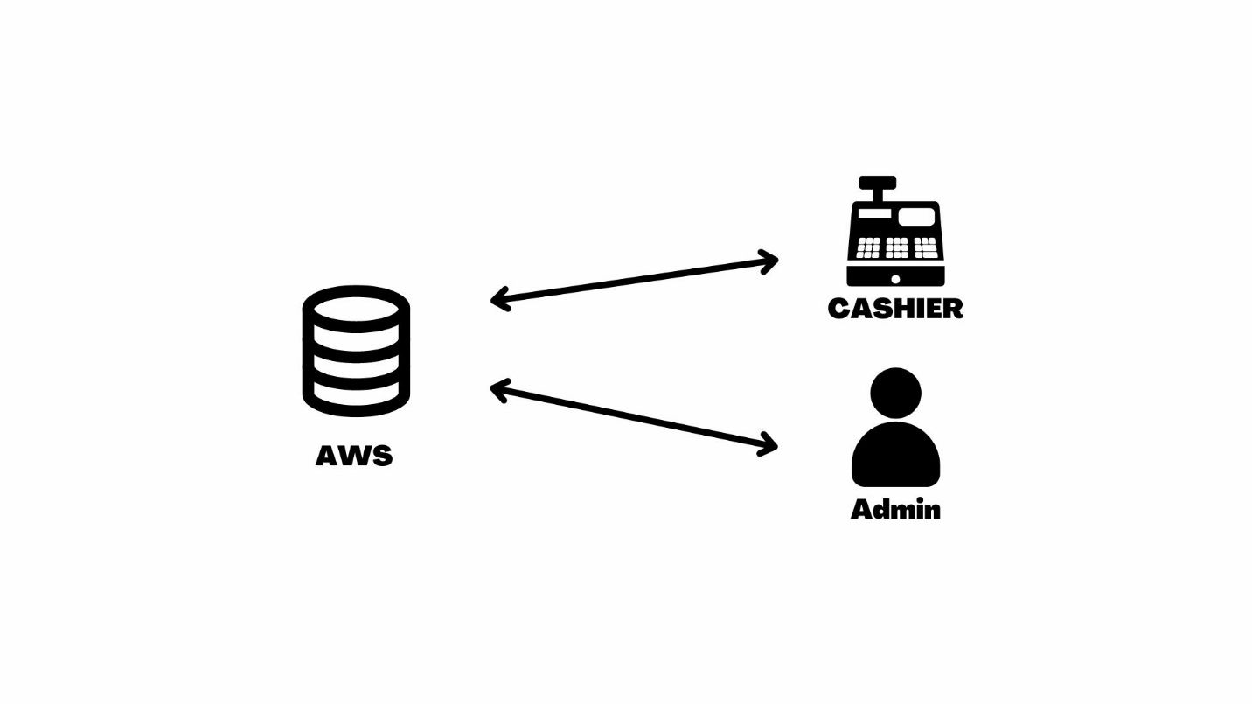This part of the paper will converse about the technical background, software, hardware, and network that will be implemented, required, and used in the creation of the project.

Figure 4 Proposed System

The proposed solution of the developers is a responsive webapp that can manage the Bregghan mini grocery store’s stocks and sales. The webapp will only be accessed by the admin which is the admin(client) and the cashier which has the control of the POS system device. The admin has the control of managing the inventory, viewing of sales reports, and view the analytics report wherein it shows which specific items is/are high or low in demand in a day, week, month. The cashier however has the control of the POS device where the transactions will be held and be recorded for the database.

AWS or Amazon Web Services is a type of cloud services wherein people and businesses can rent for their computing services like databases, servers, and storage. Furthermore AWS offers several services for each client which can be accessed through the internet. The developers chose AWS for the Bregghan mini grocery store since it is good for scalability, with the mini grocery store planning to scale up in the future, the business should not worry about managing their infrastructure since the store can scale up and scale down with ease while still meeting their changing demands. Moreover, with the high performance and reliability of the AWS it can handle high volumes of traffic and dataset without deceleration. Lastly, the flexibility of AWS is also one of the reasons why the developers used it since it offers different database options for different specific needs which is in this capstone project is the DynamoDB.

### 3.2.1 Software

For the software, the group will utilize and implement the following:

The proposed project is a Responsive Webapp that will help the Bregghan mini Grocery store to monitor and track their sales in a digitized way which will help address their current problem.

The tools that the developers will be using for the front end is Vue JS with use of Html, CSS and JavaScript. For the back end the developers will make use of AWS Dynamo database to have a real time update for both Cashier and Admin database to be in sync. With these, the developers will be able to develop the responsive website with ease. Vue JS is a beginner friendly for programmers with the use of JavaScript, but it is also used in huge companies such as Nintendo, Netflix etc. The group will be using the said platforms and languages since it contains the functions of a website application needed for the proposed project as well as the features that can be placed in the responsive webapp.

The admin is recommended to use the following softwares since it is the minimum requirements for using a web application. In addition, using any of the software’s below will guarantee that the admin can access the web application with all its functionalities, and it will deliver the best experience for the user.

Table III Software Requirements

|  |  |
| --- | --- |
| Support Browsers (Web Application) | Supported Platforms |
| Google Chrome (newest version) | Windows, MAC OS, IOS, Android |
| Microsoft Edge (newest version) | Windows |
| Mozilla Firefox (newest version) | Windows |
| Safari (Apple) newest version | MAC OS, IOS |

### 3.2.2 Hardware

For the hardware, the group will make use of the following:

The hardware that the group will make use of will be an Android tablet and a laptop. The table below will show the minimum and recommended requirements for the required hardware.

Table IV Hardware Specifications Tablet

|  |  |  |
| --- | --- | --- |
|  | Minimum specifications | Recommended specifications |
| Android Version | Android 5.0 - 5.1.1 Lollipop | Android 8.0 Oreo up to date |
| Processor | Qualcomm Snapdragon 615 | Qualcomm Snapdragon 835 or better |
| Memory | 6-GB RAM | 8-GB RAM or more |
| Storage | At least 500 mb | 1-GB or more |

Table V Hardware Specifications Computer

|  |  |  |
| --- | --- | --- |
|  | Minimum specifications | Recommended specifications |
| Processor | Intel i3-6th gen  AMD Athlon | Intel i5-6th gen  AMD Ryzen 1200 |
| Graphics | Intel UHD Graphics 620 | Nvidia MX 330 |
| Memory | 4-GB RAM | 8-GB RAM or more |
| Storage | At least 250 gb hard disk | 1. hard disk or more |

Table VI Hardware Printer

|  |  |  |
| --- | --- | --- |
|  | Minimum specifications | Recommended specifications |
| Bluetooth connection | Bluetooth 2.0 | Bluetooth 5.0  AMD Ryzen 1200 |
| Power Connection | DC12~12V | DC12~12V |

Table VII Scanner

|  |  |  |
| --- | --- | --- |
|  | Minimum specifications | Recommended specifications |
| Bluetooth connection | Bluetooth 2.0 | Bluetooth 5.0  AMD Ryzen 1200 |
| Battery capacity | 1000 MAH | 2000 MAH |
| Sensor resolution | 960*640 | 960*640 |

### 3.2.3 Network

For the network, the group will utilize and implement the following:

The usage of internet connection will be required for the responsive webapp to connect with each other since the developers will make use of a web server and database. The cashier and the admin should be able to have a synchronized data exchange and the changes made from the cashier’s dashboard should reflect on the admin’s dashboard in real-time for the system to run effectively.

# Methodology

The group chose Agile Methodology, for the project to be monitored in real time. Because the client will be involved throughout the project since the group has a fast contact with the client in cases of clarity and feedback. And it is also an advantage in case the client wants changes in the project. Scrum methodology will be used for the project.

The group started off with *data gathering.* Started by talking to the client and after, the group also talked to the adviser, and took the advice of the adviser to be applied on the proposed project. For the first term, the group will be finishing the documentation for what the whole project will look like from solving problems and finding solutions to reach the desired state of the client’s business which are the requirements before continuing to the next cycles.

The development team’s plan is to create a POS-like application that will help the user monitor the stocks and automate sales to be reported for each day, week, month, and year. The team have chosen to use the software Android Studio. So, for the Language that will be used in the code is Java. Since Android Studio’s main language is java.

Since the scrum methodology will be used, the project will be divided into small tasks. For the design, the second term (MYSADD1) will be for modeling so the designing of the application will take place meaning the breakdown of features and functions proposed will be designed in the application before the development cycle, which will lead us to the 3rd semester (MCSPROJ), this is where all the coding and development, testing and deployment will be. The proposed features and functions will be implemented in this cycle as well as the overall project before the final project is done.

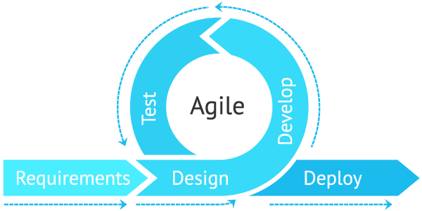

## Requirements Analysis

### Product Backlog / User Stories

**Admin:**

As an Admin, I want to view the inventory, so that I would be able to know the item's stock level.

**Acceptance Criteria:**

* Inventory Tab is enabled in the system.
* When inventory tab is pressed the page is available for view

**Admin:**

As an Admin, I want to add items, so that I can replenish my stocks.

**Acceptance Criteria:**

* Admin can add items by pressing add item button.
* Item price and quantity field is required to add items.
* Inventory page is updated.

**Admin:**

As an Admin, I want to include a category for an item, so that my cashier would know a specific category of an item.

**Acceptance Criteria:**

* Admin can include or edit an item category
* Specific Items can be added to said category
* Inventory is updated.

**Admin:**

As an Admin, I want to set prices for my items, so that the cashier can compute the items bought by a customer.

**Acceptance Criteria:**

* A tab is available to admin to set item prices.
* Admin can set prices for each item.
* System will display prices for items in retail, bulk, and wholesale.

**Admin:**

As an Admin, I want to create an account, so that I can secure the cashier and admin system.

**Acceptance Criteria:**

* Create account button is available upon login.
* Admin enters credentials (Admin Id & Password)
* Account Created

**Admin:**

As an Admin, I want to indicate a low critical point for each item, so that I can reorder items.

**Acceptance Criteria:**

* Item reaches Low Critical Point
* System sends alert to admin for specific item.

**Admin:**

As an Admin, I want to edit or update product items in the system, so that I can manage the item information.

**Acceptance Criteria:**

* Edit tab is available to admin for each item.
* Admin can edit/update products in system.
* Display newly updated and edited items on the Admin Page.

**Admin:**

As an Admin, I want to view the sales, so that I would be able to know the overall sales and items deducted.

**Acceptance Criteria:**

* A tab is enabled on admin page.
* Once pressed system will direct to current page.
* Sales Report is viewable in the admin page.

**Admin:**

As an Admin: I want to have an analytics report, so that I would be able to know the fast- and slow-moving items.

**Acceptance Criteria:**

* A tab is available to admin.
* Once pressed system will direct to page.
* Analytics Report is viewable in the admin page.

**Cashier:**

As a Cashier, I want to scan the items bought by the customer, so that I can get rid of the manual listing with the use of a pen and paper.

**Acceptance Criteria:**

* Cashier uses barcode scanner to scan items.
* Once scanned system will Display the item’s prices in the Cashier POS.

**Cashier:**

As a Cashier, I want to digitize the computation of sales, so that I can get rid of the manual listing with the use of a pen and paper.

**Acceptance Criteria:**

Display the item’s prices in the Cashier POS.

**Cashier:**

As a cashier, I want to manage the payment of the customers, so that I can complete a transaction.

**Acceptance Criteria:**

* Cashier receives payment from customer.
* Payments reflect in the Cashier POS

**Cashier:**

As a cashier, I want to generate a receipt, so that I can give a copy to the customers.

**Acceptance Criteria:**

* Item is scanned by cashier.
* POS system processes transaction
* Receipt with transacted items and prices printed for customers.

**Cashier:**

As a cashier, I want to scan the customer’s items, so that I can process the customer’s orders.

**Acceptance Criteria:**

* Barcode scanner is used to scan items.
* Scanned items will reflect on the Cashier POS transaction page.

**Cashier:**

As a cashier, I want to edit the transacted items on the POS, so that I can remove the unnecessary items.

**Acceptance Criteria:**

* A button is enabled to cashier on checkout page.
* Once pressed cashier can edit items on POS.
* Unwanted items removed in the POS transaction page.

### Event Tables

Table VIII Event Table

|  |  |  |  |  |  |
| --- | --- | --- | --- | --- | --- |
| Event | Trigger | Source | Use Case | Response | Destination |
| Recording of sales | Scan items in POS | Customer | Punching of grocery items | Sales Details | Cashier |
| Paying of items purchased | Pay the items on hand | Customer | Manage Payment | Item purchased details | Cashier |
| Generating a receipt | Generate a receipt. | Cashier | Manage Receipt | Receipt details | Customer |
| View Sales Report Page | Show Sales Report | Admin | Admin wants to see sales report | Display Sales Report | Admin System |
| Managing  Inventory | Show  Inventory | Admin | Manage  Inventory | Bring to  Inventory Screen | Admin System |
| Adding new items to inventory. | Admin | Record of new items in inventory. | Admin System |
| Removing items in inventory. | Admin | Deleting records of items in inventory. | Admin System |
| Updating the item  information | Admin | Change of item  information | Admin System |
| Show the low stock item | Admin | Alerts the admin | Admin System |
| View Analytics Report Page | Show Analytics Report | Admin | Admin wants to see Analytics | Display  Analytics Report | Admin System |

### Use Case Diagrams

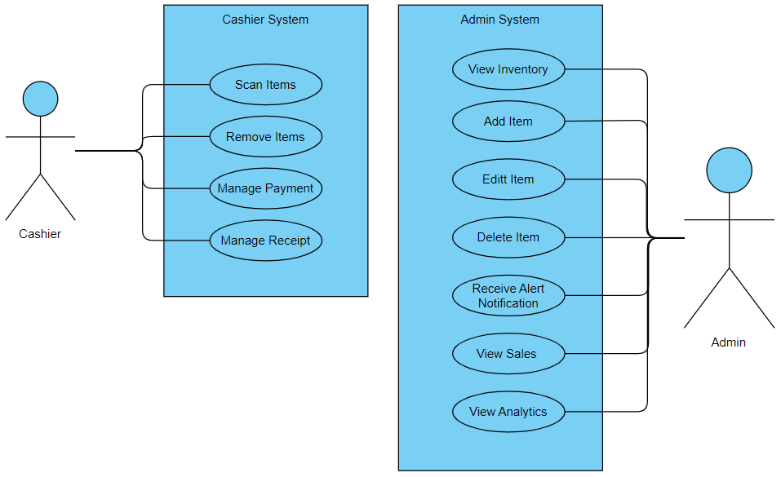

Figure 5 Use Case Diagram

### Use Case Full Description

Table IX Use Case Full Description 1

|  |  |
| --- | --- |
| Number | UC0-01 |
| Name | Scan Items |
| Description | Cashier will scan the customer’s items through the POS System. |
| Precondition | Cashier logged in |
| Postcondition | Display item’s information  Display in the receipt  Display the subtotal of items bought |
| Actor/s | Cashier |
| Trigger | Cashier scans the customer’s items. |
| Main Scenario | |  |  |  |  |  | | --- | --- | --- | --- | --- | | Actor | System |  |  |  | | 1. Cashier scans the item’s barcode. | 1. System displays the scanned items. |  |  |  | |  | 2. System will display the  subtotal. |  |  |  | |
| Exception | 1. If item is not registered, refer to step: Add Item  (UCO-06). |

Table X Use Case Full Description 2

|  |  |
| --- | --- |
| Number | UC0-02 |
| Name | Remove item |
| Description | Remove unwanted items from the scanned items. |
| Precondition | Item is scanned. |
| Postcondition | Cashier will remove the selected item from the POS. |
| Actor/s | Cashier |
| Trigger | Cashier removes the unwanted item of customer |
| Main Scenario | |  |  |  |  | | --- | --- | --- | --- | | Actor | System |  |  | | 1. Cashier will remove the unwanted item. | 1.System will remove the unwanted items from the scanned items. |  |  | |

Table XI Use Case Full Description 3

|  |  |
| --- | --- |
| Number | UC0-03 |
| Name | Manage Payment |
| Description | Customers will pay the items bought. |
| Precondition | Display calculated total amount. |
| Postcondition | Cashier will confirm the payment. |
| Actor/s | Cashier |
| Trigger | Pay the items on hand |
| Main Scenario | |  |  |  |  | | --- | --- | --- | --- | | Actor | System |  |  | | 1. Customer will hand payment to the cashier. | 1. System will display the  total amount of items bought. |  |  | |
| Exceptions | 1. Transaction will not be completed if the customer will not pay the items bought. |

Table XII Use Case Full Description 4

|  |  |
| --- | --- |
| Number | UC0-04 |
| Name | Manage Receipt |
| Description | Produce receipt. |
| Precondition | Payment confirmed. |
| Postcondition | Printed receipt. |
| Actor/s | Cashier |
| Trigger | System will generate receipt. |
| Main Scenario | |  |  |  |  | | --- | --- | --- | --- | | Actor | System |  |  | | 1. Customer will confirm the transaction. | 1. System will generate receipt. |  |  | |
| Exceptions | 1.System will not generate receipt if transaction is not finished. |

Table XIII Use Case Full Description 5

|  |  |
| --- | --- |
| Number | UC0-05 |
| Name | Manage Receipt |
| Description | Produce receipt. |
| Precondition | Payment confirmed. |
| Postcondition | Printed receipt. |
| Actor/s | Cashier |
| Trigger | System will generate receipt. |
| Main Scenario | |  |  |  |  | | --- | --- | --- | --- | | Actor | System |  |  | | 1. Customer will confirm the transaction. | 1. System will generate receipt. |  |  | |
| Exceptions | 1.System will not generate receipt if transaction is not finished. |

Table XIV Use Case Full Description 6

|  |  |
| --- | --- |
| Number | UC0-06 |
| Name | View Inventory |
| Description | Admin view inventory |
| Precondition | Admin logged in |
| Postcondition | Displays inventory page |
| Actor/s | Admin |
| Trigger | Show Inventory. |
| Main Scenario | |  |  |  |  | | --- | --- | --- | --- | | Actor | System |  |  | | 1. Admin view Inventory page | 1. System displays inventory  page. |  |  | | 2. Admin can filter according to item category | 2. System will display information according to category |  |  | | 3. Admin can filter according to A-Z. | 3. System will display according  to A-Z. |  |  | | 4. Admin can filter according to Z-A. | 4. System will display according  to Z-A. |  |  | |  |  | |
| Exceptions | 1. Admin must log in to the admin system to view inventory. |

Table XV Use Case Full Description 7

|  |  |
| --- | --- |
| Number | UC0-07 |
| Name | Add Items |
| Description | Admin will add an item record to be saved in the database. |
| Precondition | Selected add item in inventory page |
| Postcondition | System will save the added item record.  System will display the newly added item. |
| Actor/s | Admin |
| Trigger | Add new item record |
| Main Scenario | |  |  |  |  | | --- | --- | --- | --- | | Actor | System |  |  | | 1. Admin will add new item record | 1. System will save and display new item record |  |  | |
| Exceptions | 1. Admin must log in to the admin system to view inventory. |

Table XVI Use Case Full Description 8

|  |  |
| --- | --- |
| Number | UC0-08 |
| Name | Edit Item |
| Description | Admin will edit/update an item information. |
| Precondition | Admin selected an item to be edited. |
| Postcondition | System will save the edited added item record.  System will display the newly edited item. |
| Actor/s | Admin |
| Trigger | Edit item information. |
| Main Scenario | |  |  |  |  | | --- | --- | --- | --- | | Actor | System |  |  | | 1. Admin will select an item to be updated. | 1. Display the current item details of the item. |  |  | |
| Exceptions | 1. System will not change the edited/updated information if not saved. |

Table XVII Use Case Full Description 9

|  |  |
| --- | --- |
| Number | UC0-09 |
| Name | Delete item |
| Description | Admin will delete an item. |
| Precondition | Admin selected an item. |
| Postcondition | System will delete an item information |
| Actor/s | Admin |
| Trigger | Delete an item |
| Main Scenario | |  |  |  |  | | --- | --- | --- | --- | | Actor | System |  |  | | 1. Admin can delete an item information | 1. System will delete the item information. |  |  | |
| Exceptions | 1. System will not delete an item if not confirmed. |

Table XVIII Use Case Full Description 10

|  |  |
| --- | --- |
| Number | UC0-10 |
| Name | View Sales |
| Description | System will generate reports which can be accessed by the admin. |
| Precondition | Clicked on reports tab. |
| Postcondition | Display sales report |
| Actor/s | Admin |
| Trigger | Admin access reports. |
| Main Scenario | |  |  | | --- | --- | | Actor | System | | 1. Admin proceeds to sales reports Page. | 1. System will display sales  reports page. | | 1. Admin proceeds to sales reports Page. | 1. System will display sales reports page. | | 2. Filter sales from oldest to newest. | 2. Display sales from oldest to newest. | | 3. Filter sales from newest to oldest. | 3. Display sales to newest to  oldest. | |
| Exceptions | 1. System will not generate sales report if the store has no income. |

Table XIX Use Case Full Description 11

|  |  |
| --- | --- |
| Number | UC0-11 |
| Name | View Analytics |
| Description | System will generate analytics reports which can be accessed by the admin. |
| Precondition | Clicked on reports tab. |
| Postcondition | Display analytics |
| Actor/s | Admin |
| Trigger | Admin access Reports. |
| Main Scenario | |  |  | | --- | --- | | Actor | System | | 1. Admin can view analytics reports. | 1. System will display sales reports page. | |
| Exceptions | 1. System will not generate sales report if the store has no income. |

Table XX Use Case Full Description 12

|  |  |
| --- | --- |
| Number | UC0-12 |
| Name | Receive notification alert |
| Description | System will alert or send notification to the admin if a specific item reaches its critical amount. |
| Precondition | Item stock has reached a critical point. |
| Postcondition | Sends alert/notification |
| Actor/s | Admin |
| Trigger | Low supplies. |
| Main Scenario | |  |  | | --- | --- | | Actor | System | | 1. System alerts the admin | 1. Display low critical items | |
| Exceptions | 1. System will only send an alert/notification if a specific item reaches its critical amount. |

### 4.1.5 Gap Analysis

Table XXI Gap Analysis

|  |  |  |  |
| --- | --- | --- | --- |
| Product Backlog ID | Current System | Proposed Changes | Impact |
| 4 | Staff monitoring of Items | View Inventory | Admin doesn’t have to count the items manually |
| 15 | Writing of receipt | Printing of receipt | Customer will have a better copy of their receipt |
| 12 | Computation of items | Scan the items customer wants to check out | Cashier doesn’t have to compute for the total anymore |
| 6 | Replenishment of Items/Stock | Notifies for critical supply. | Admin do not have to count the number of stocks manually anymore |

## System Analysis and Design

### 4.2.1 Context Diagram

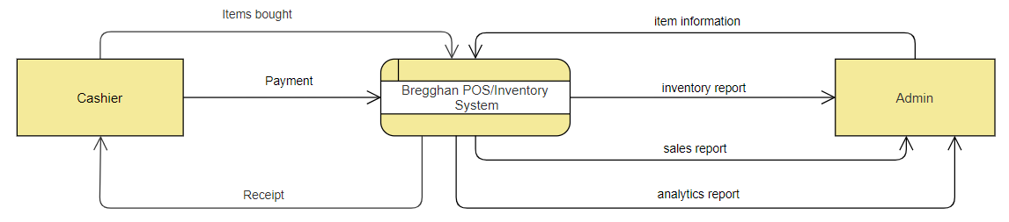

Figure 6 Context Diagram

### 4.2.2 Data Flow Diagrams

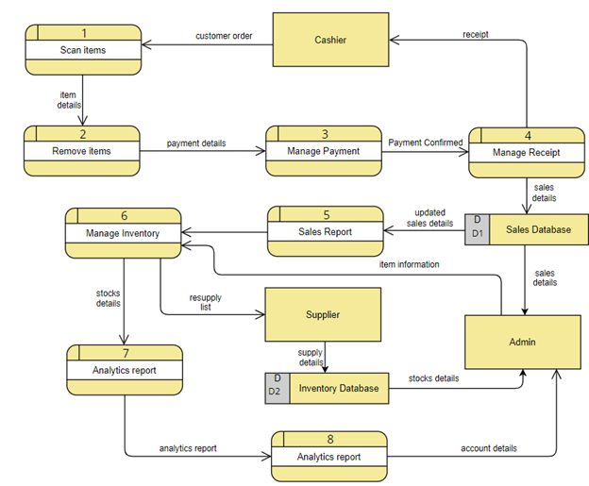

Figure 7 Data Flow Diagram Level O

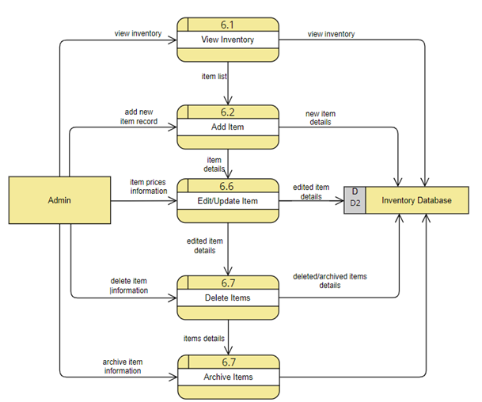

Figure 8 DFD Level 1 Manage Inventory

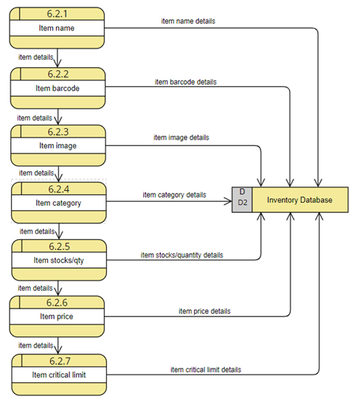

Figure 9 Add Item

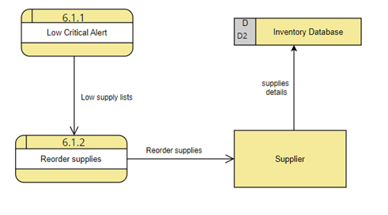

Figure 10 View Inventory

### 4.2.3 Entity-Relationship Diagrams

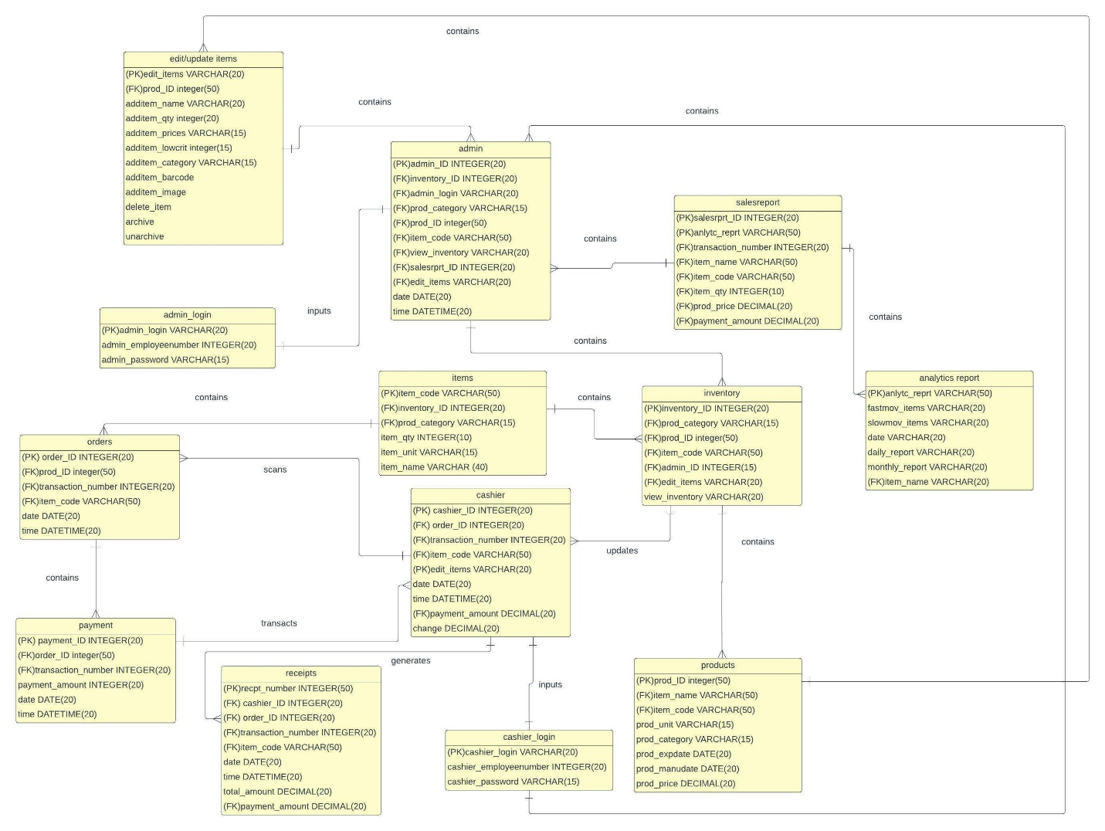

Figure 11 Entity Relationship Diagram

### 4.2.4 Activity Diagrams

Activity diagrams are graphical representations of sequential activities and actions found in this section. It determines the style of flowchart that indicates who handles what duties throughout a process. A swim lane diagram places process steps within the "swim lanes" of a specific user or system, like the lanes in a pool, and offers clarity and responsibility.

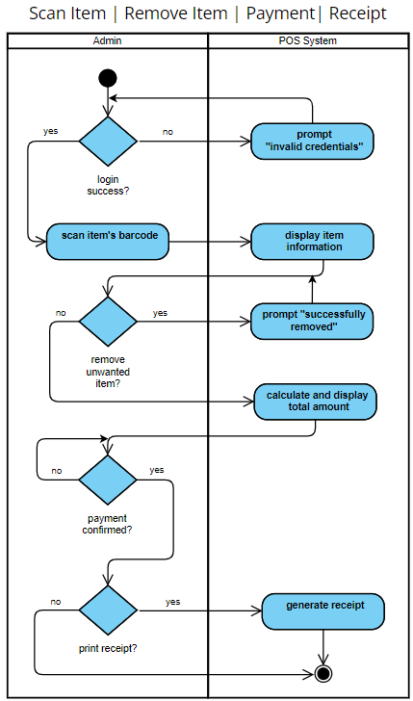

Figure 12 Scan Item / Remove Item / Payment / Receipt

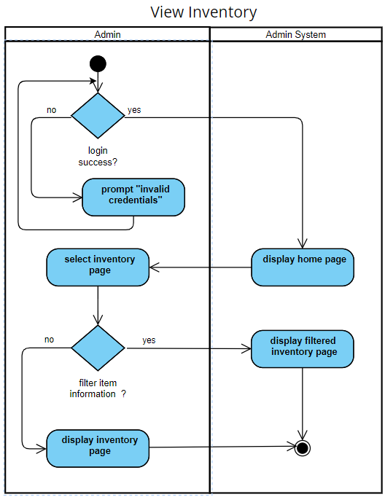

Figure 13 View Inventory

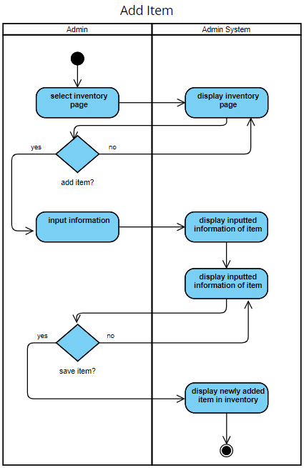

Figure 14 Add Item

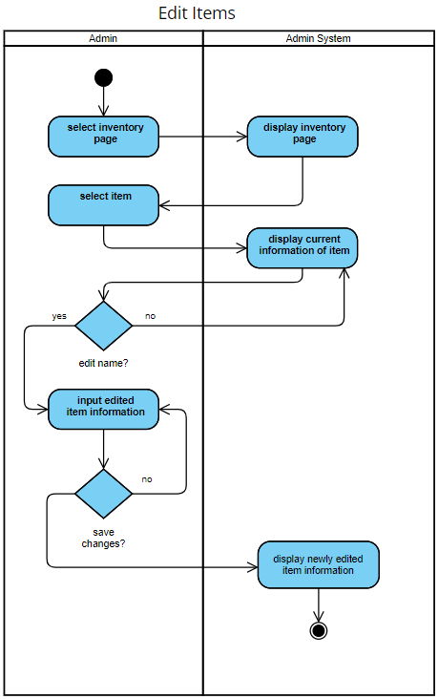

Figure 15 Edit Items

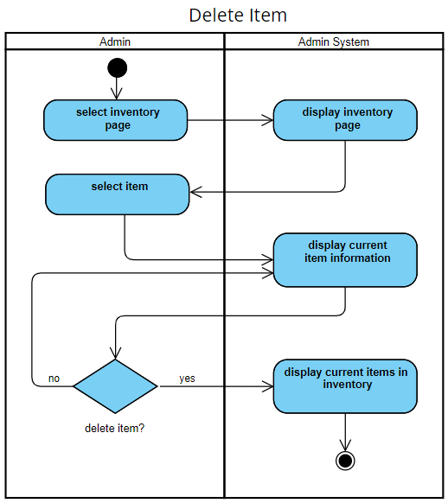

Figure 16 Delete Item

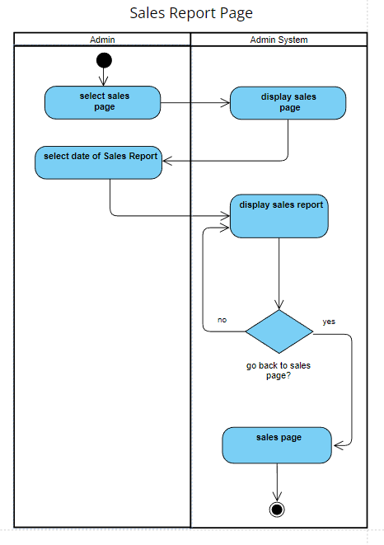

Figure 17 Sales Report Page

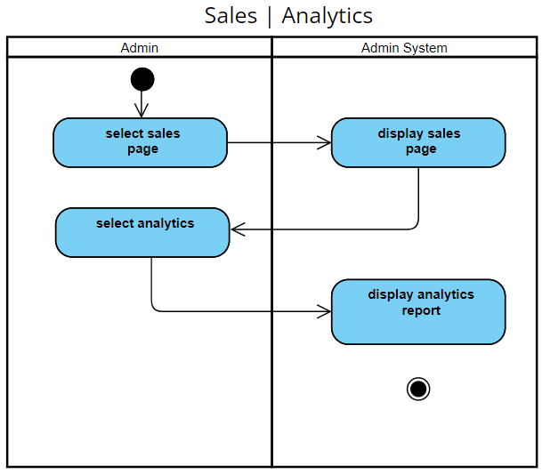

Figure 18 Analytics Report Page

### 4.2.5 Object Diagram

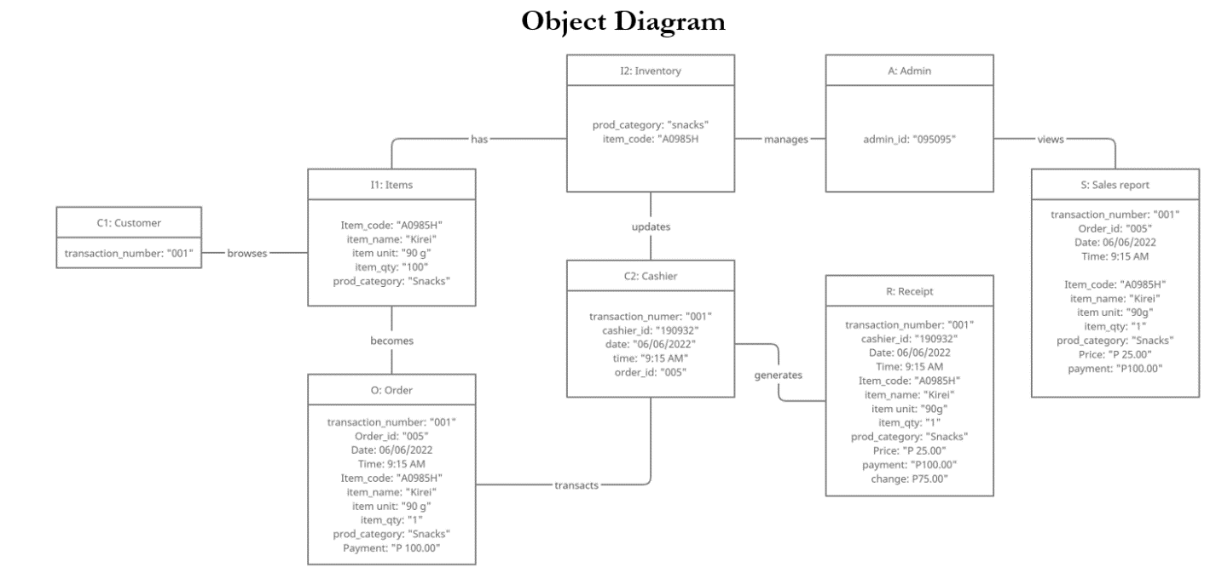

Figure 19 Object Diagram

### 4.2.6 Class Diagrams

The class diagram is depicted in the image below. This will result in a static structural diagram in the UML that shows the relationships between each class and object as well as the general classes, properties, and activities of the system.

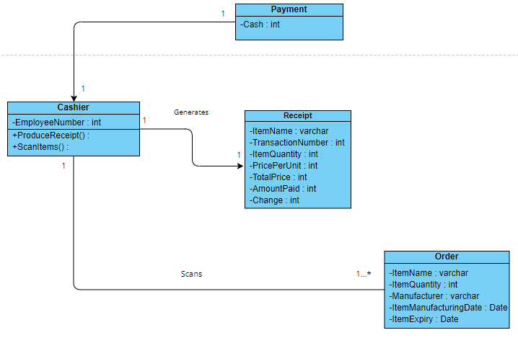

Figure 20 Class Diagram

### 4.2.7 Sequence Diagrams

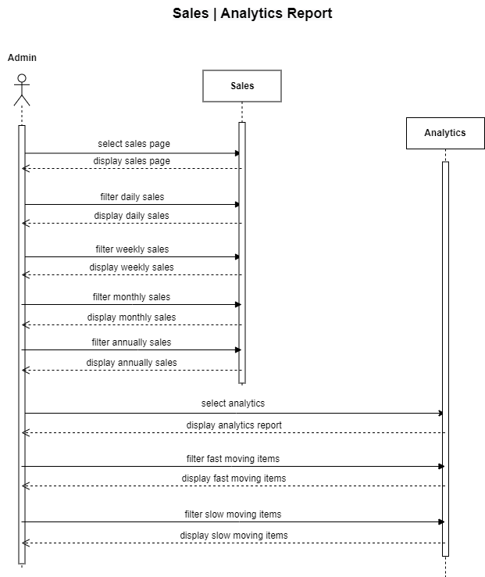

Figure 21 Sales / Analytics Report

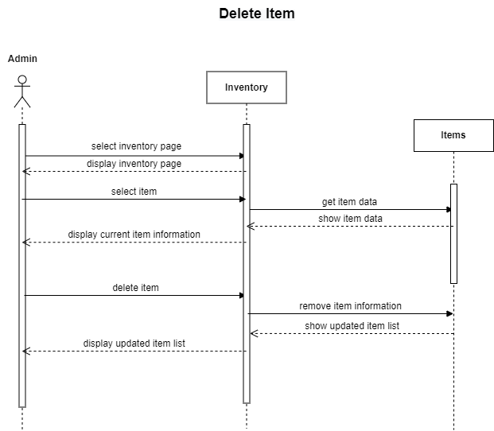

Figure 22 Delete Item

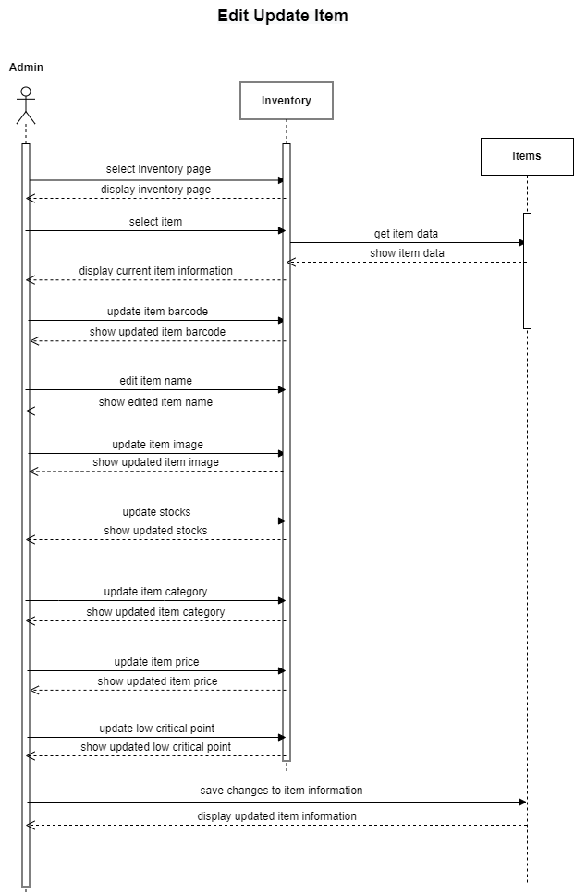

Figure 23 Edit Update Item

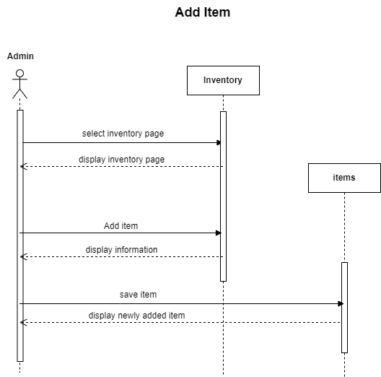

Figure 24 Add Item

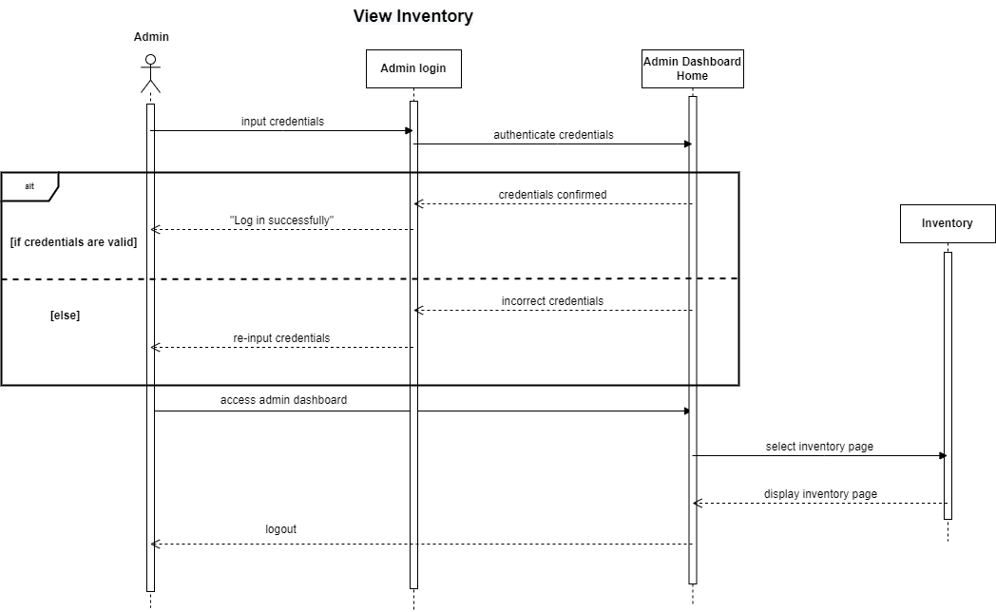

Figure 25 View Inventory

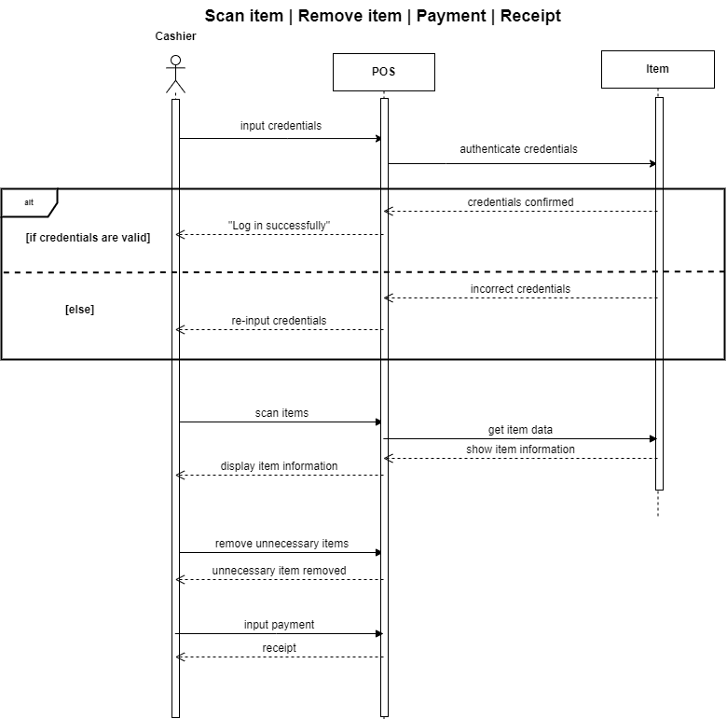

Figure 26 Scan Item / Remove Item / Payment / Receipt

### 4.2.8 State Machine Diagram

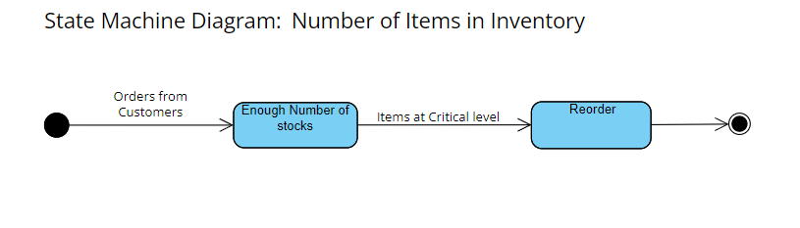

Figure 27 State Machine Diagram: Number of items in Inventory

### 4.2.9 Package Diagram

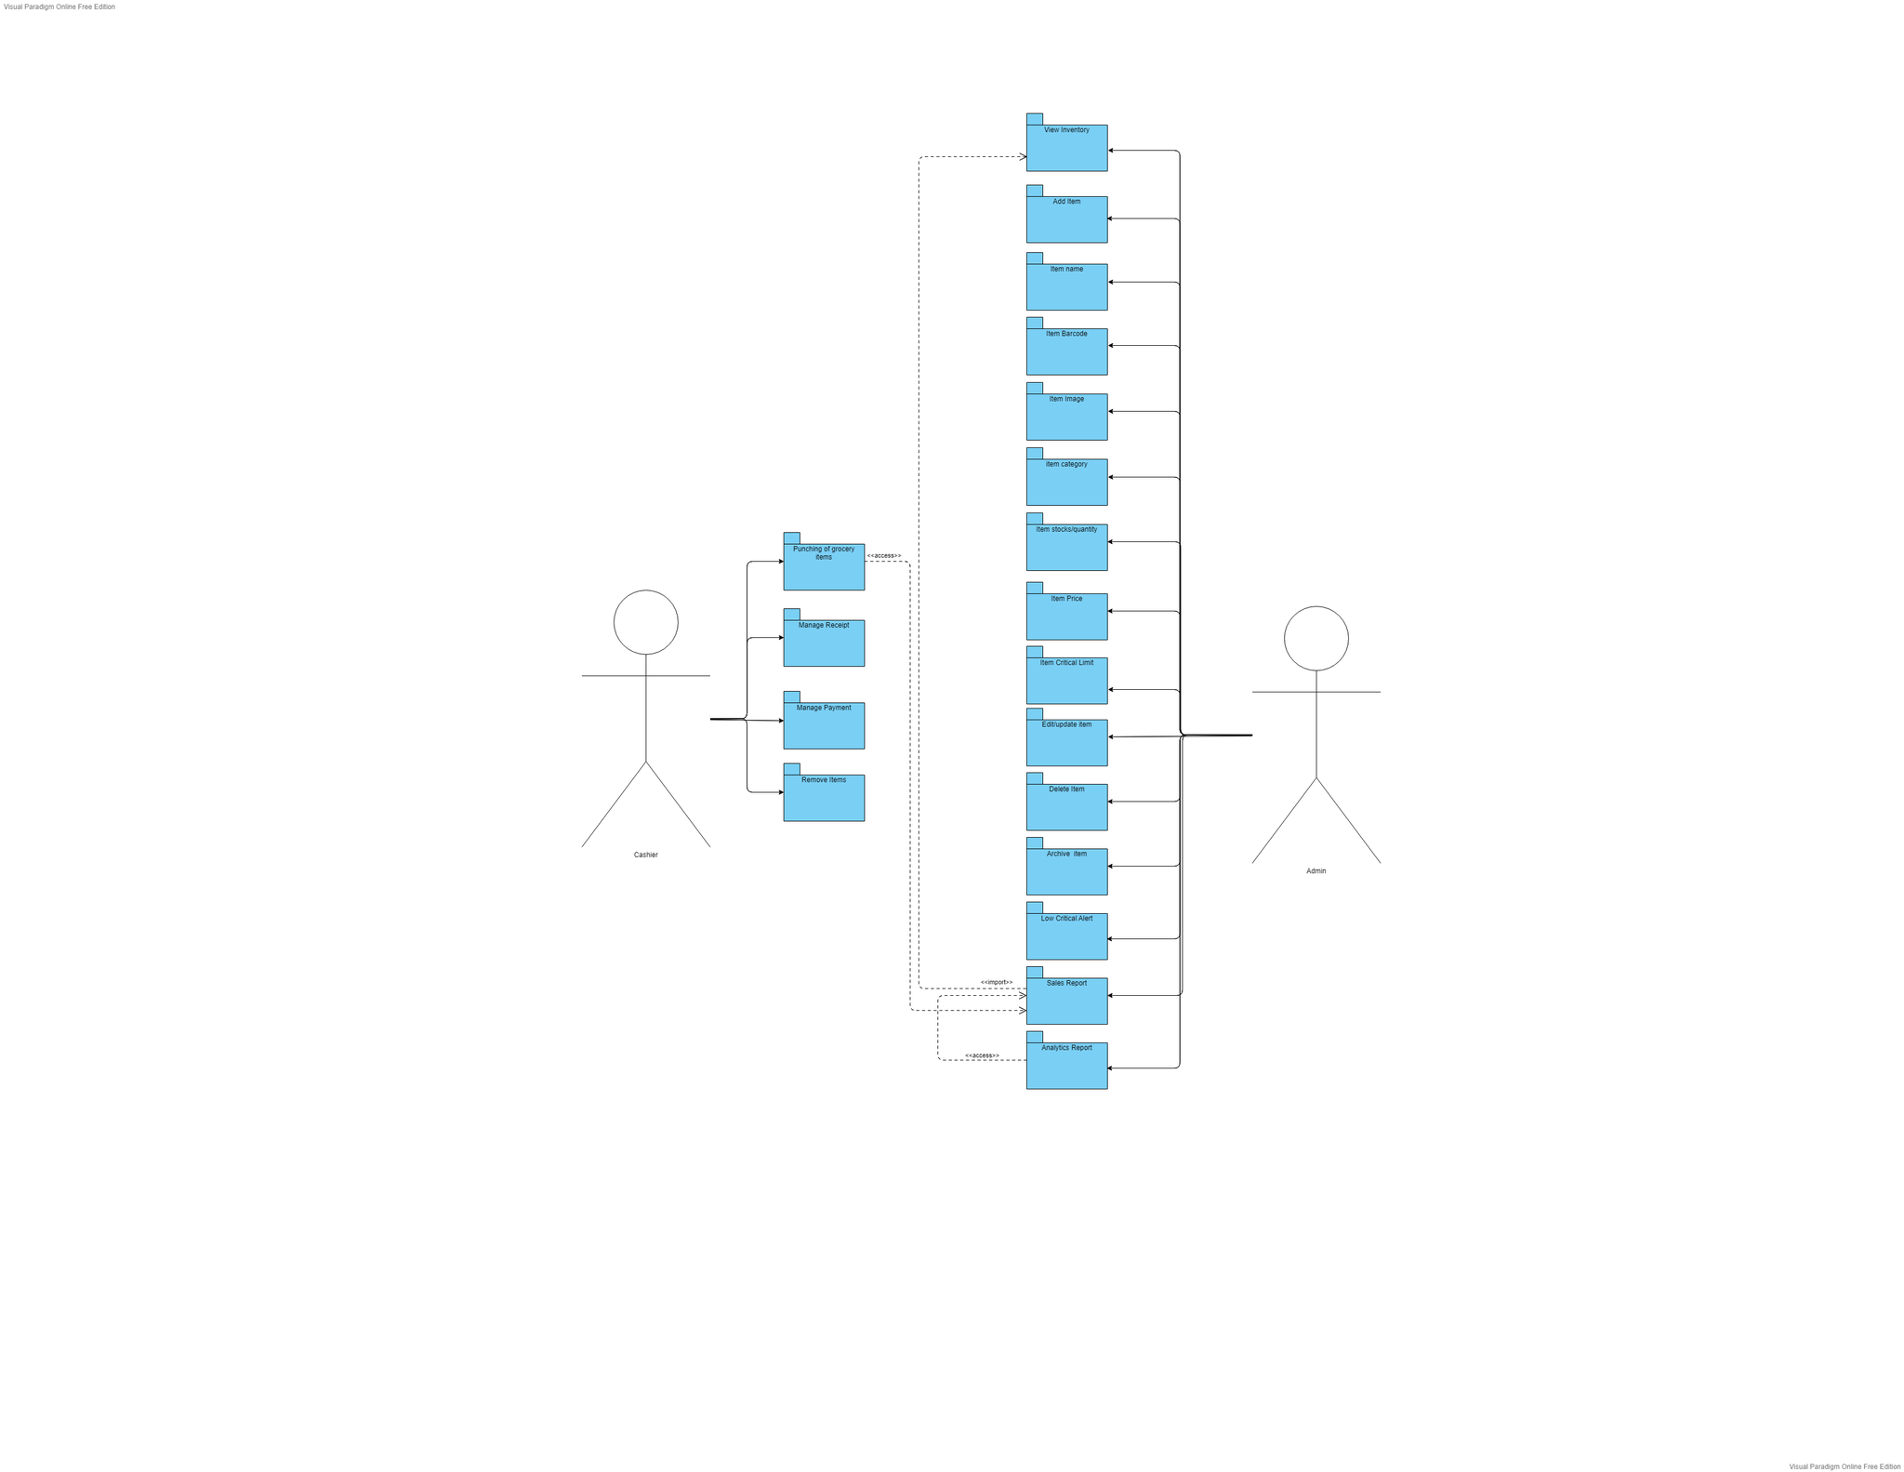

Figure 28 Package Diagram

### 4.3.10 Component Diagram

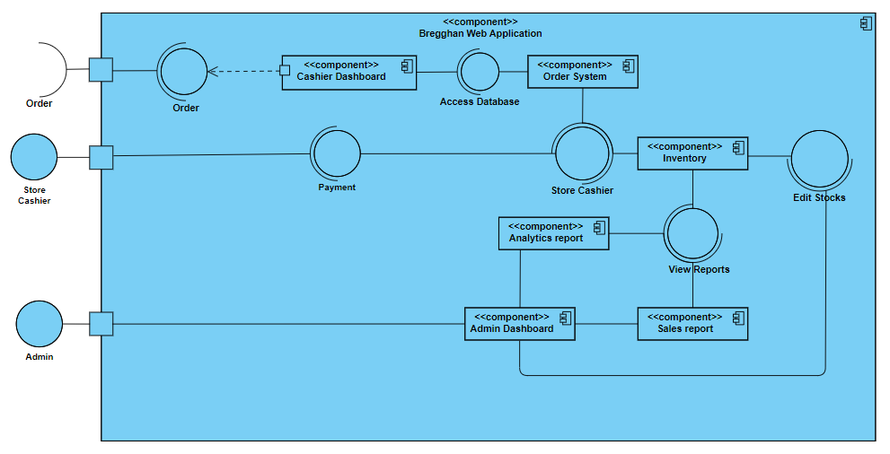

Figure 29 Component Diagram

### 4.3.11 Deployment Diagram

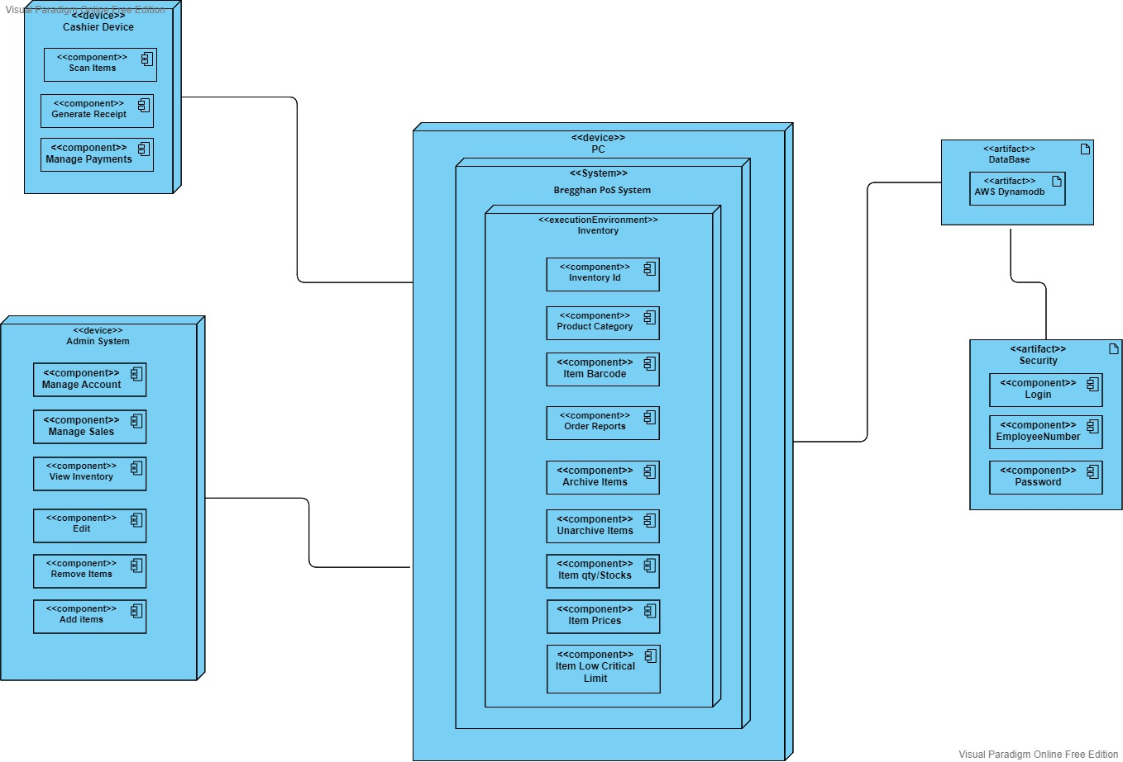

Figure 30 Deployment Diagram

### 4.3.12 Data Dictionaries

Data Dictionary: admin_login

Table XXII Data Dictionary: admin login

|  |  |  |  |
| --- | --- | --- | --- |
| PK/FK | Field Name | Data Type | Description |
| PK | admin_login | varchar | Unique identifier for admin login |
|  | admin_employeenumber | int | admin id number |
|  | admin_password | varchar | admin password |

Data Dictionary: cashier_login

Table XXIII Data Dictionary: cashier login

|  |  |  |  |
| --- | --- | --- | --- |
| PK/FK | Field Name | Data Type | Description |
| PK | cashier_login | varchar | cashier login key identifier |
|  | cashier_employeenumber | int | cashier id number |
|  | cashier_password | varchar | cashier password |

Data Dictionary: admin

Table XXIV Data Dictionary: admin

|  |  |  |  |
| --- | --- | --- | --- |
| PK/FK | Field Name | Data Type | Description |
| PK | admin_ID | int | admin key identifier |
| FK | inventory_ID | int | inventory identifier |
| FK | prod_category | varchar | product category |
| FK | prod_ID | integer | product identifier |
| FK | Item_code | varchar | unique code of item |
| FK | salesrprt | int | sales report identifier |
| FK | mnge_accounts | varchar | edit for managed accounts |
| FK | edit_items | Varchar | for edit/update items |
|  | date | date | date of transaction |
|  | time | time | time of transaction |

Data Dictionary: sales report

Table XXV Data Dictionary: sales report

|  |  |  |  |
| --- | --- | --- | --- |
| PK/FK | Field Name | Data Type | Description |
| PK | salesrprt | int | sales report key identifier |
| PK | analytc_reprt | varchar | analytics report key identifier |
| FK | transaction_number | int | transaction number |
| FK | item_name | varchar | name of the item’s bought |
| FK | item_code | varchar | unique code of item’s bought |
| FK | item_qty | Int | quantity of item bought |
| FK | prod_price | decimal | date of transaction |
| FK | payment_amount | decimal | payment amount of the customer |

Data dictionary: analytics report

Table XXVI Data dictionary: analytics report

|  |  |  |  |
| --- | --- | --- | --- |
| PK/FK | Field Name | Data Type | Description |
| PK | analytc_reprt | varchar | key identifier of analytics report |
|  | fastmov_items | varchar | fast moving items |
|  | slowmov_items | varchar | slow moving items |
|  | date | date | date |
|  | daily_report | varchar | daily sales report |
|  | monthly_report | varchar | monthly sales report |
| FK | item_name | varchar | name of the item |

Data dictionary: Orders

Table XXVII Data dictionary: Orders

|  |  |  |  |
| --- | --- | --- | --- |
| PK/FK | Field Name | Data Type | Description |
| PK | order_ID | Int | key identifier of order ID |
| FK | prod_ID | Int | ID number of item’s bought |
| FK | transaction_number | Int | Transaction number for each order |
| FK | item_code | Varchar | unique code of item |
|  | date | date | date of transaction |
|  | time | time | time the transaction started |

Data dictionary: Payment

Table XXVIII Data dictionary: Payment

|  |  |  |  |
| --- | --- | --- | --- |
| PK/FK | Field Name | Data Type | Description |
| PK | payment_ID | int | key identifier of payment id |
| FK | order_ID | int | ID number of item’s bought |
| FK | transaction_number | int | Transaction number for each order |
|  | payment_amount | decimal | Amount paid by the customer |
|  | date | date | Date of transaction |
|  | time | Time | Time the transaction started |

Data dictionary: Receipt

Table XXIX Data dictionary: Receipt

|  |  |  |  |
| --- | --- | --- | --- |
| PK/FK | Field Name | Data Type | Description |
| PK | receipt_number | int | key identifier of receipt number |
| FK | cashier_ID | int | ID number of item’s bought |
| FK | order_ID | int | order id |
| FK | transaction_number | varchar | transaction number for each order |
| FK | item_code | varchar | unique item code |
| FK | total_amount | decimal | total amount of orders |
|  | change | decimal | change of the customer |
|  | date | date | date of transaction |
|  | time | time | time the transaction started |

Data dictionary: cashier

Table XXX Data dictionary: cashier

|  |  |  |  |
| --- | --- | --- | --- |
| PK/FK | Field Name | Data Type | Description |
| PK | cashier_ID | int | key identifier of cashier id |
| FK | order_ID | int | ID number of item’s bought |
| FK | transaction_number | int | Transaction number for each order |
|  | Item_code | varchar | unique code of item |
|  | date | date | date of transaction |
|  | time | time | time of transaction |
| FK | payment_amount | decimal | payment amount of customer |
|  | change | decimal | change of customer |

Data dictionary: inventory

Table XXXI Data dictionary: inventory

|  |  |  |  |
| --- | --- | --- | --- |
| PK/FK | Field Name | Data Type | Description |
| PK | inventory_id | int | key identifier of inventory id |
| FK | prod_category | int | category of an item |
| FK | prod_id | int | Id number of product |
| FK | Item_code | varchar | unique code of item |
| FK | admin_ID | varchar | ID number of the admin |

Data dictionary: items

Table XXXII Data dictionary: items

|  |  |  |  |
| --- | --- | --- | --- |
| PK/FK | Field Name | Data Type | Description |
| PK | item_code | varchar | key identifier of item code |
| FK | inventory_ID | int | ID number of inventory |
| FK | prod_category | int | category of an item |
|  | item_qty | int | quantity of an item |
|  | item_unit | varchar | size description of an item |
|  | item_name | varchar | item name description |

Data dictionary: products

Table XXXIII Data dictionary: products

|  |  |  |  |
| --- | --- | --- | --- |
| PK/FK | Field Name | Data Type | Description |
| PK | Prod_ID | int | key identifier of product id |
| FK | item_name | varchar | Name description of item |
| FK | item_code | varchar | unique code of the item |
|  | Prod_unit | varchar | size of the product |
|  | Prod_category | varchar | category of a product |
|  | Prod_expdate | date | expiration date of product |
|  | Prod_manudate | date | manufacturing date of the product |
|  | Prod_price | decimal | price of the product |

Data dictionary: add/edit items

Table XXXIV Data dictionary: add/edit items

|  |  |  |  |
| --- | --- | --- | --- |
| PK/FK | Field Name | Data Type | Description |
| PK | edit_items | varchar | key identifier of edit items |
| FK | prod_ID | int | Foreign key for prod ID |
|  | additem_name | varchar | add item name for items |
|  | additem_qty | int | add item quantity for items |
|  | additem_prices | varchar | add item prices for edit items |
|  | additem_lowcrit | int | set low critical limit |
|  | additem_category | varchar | add item category for products |
|  | additem_barcode | varchar | add item barcode for items |
|  | additem_image | variable-length | add item image for item identification |

# Results and Discussion

The results and discussion contain the following: the Release plan from MYSADD 1, Release 2 for the MCSPROJ, the prototype which includes the dashboards of the Web application namely the Admin and Cashier Dashboard. Moreover, it includes the User classes and characteristics that defines the people which is the client and the cashier that will use the web application.

## 5.1 Release Plan

Release 1 – MCSPROJ

* Admin can access admin dashboard.
* Admin can view home page
* Admin can view inventory page
* Cashier can access cashier dashboard
* Cashier can view home page.
* Admin can view transaction history.
* Admin will be notified when a certain items/product reached its critical level.
* Admin can view sales report.
* Admin can add item/product in the inventory.
* Admin can edit items/products catalog.
* Admin can edit item/product prices.
* Admin can change pricelist.
* Admin can view items that are in demand.
* Admin can view items that are not in demand.
* Admin can view if item is fast moving.
* Admin can view if item is slow moving.
* Admin can categorize the products catalog.
* Cashier can use barcode scanner to scan items.
* Cashier can remove unnecessary items/products to the customer’s order.
* Cashier can view the total amount of items/products purchased.
* Cashier can input the amount the customer has paid.
* Cashier can void item(s) punched.
* Cashier can print receipts.

## 5.2 Prototype

There will be two types of dashboards. First is the admin dashboard and the other one is for the cashier staff that will be overseeing the transactions with the customers inside the store.

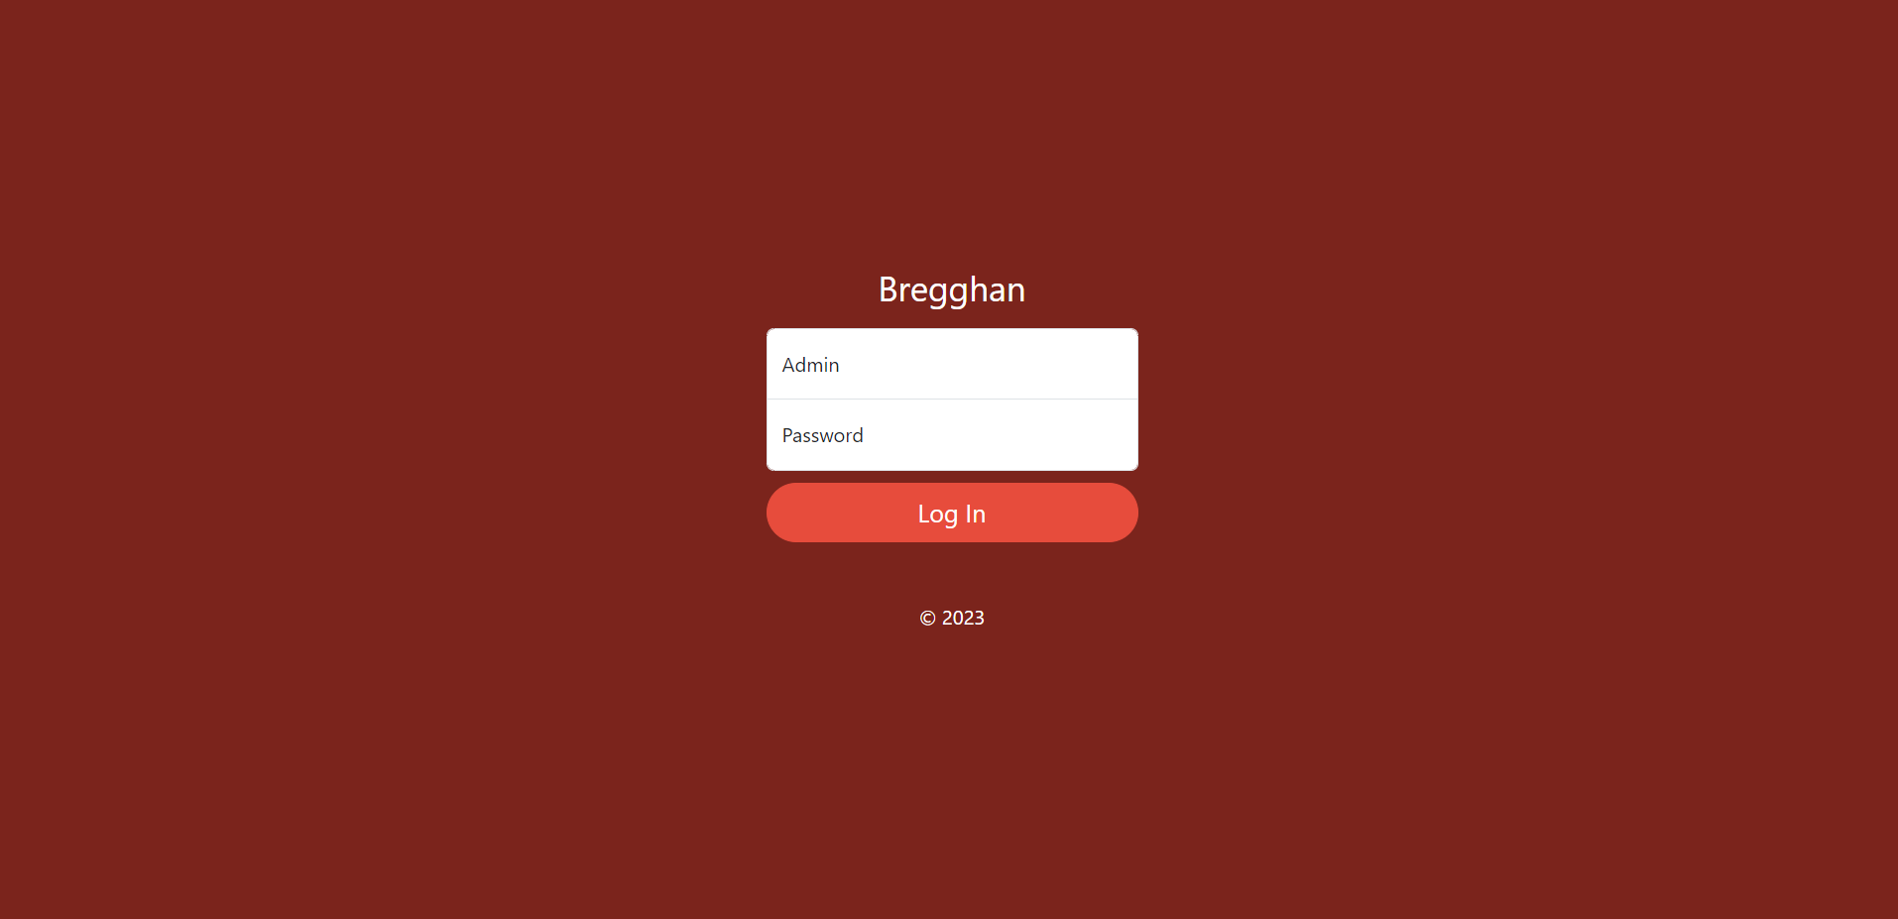

Figure 31 Login Screen

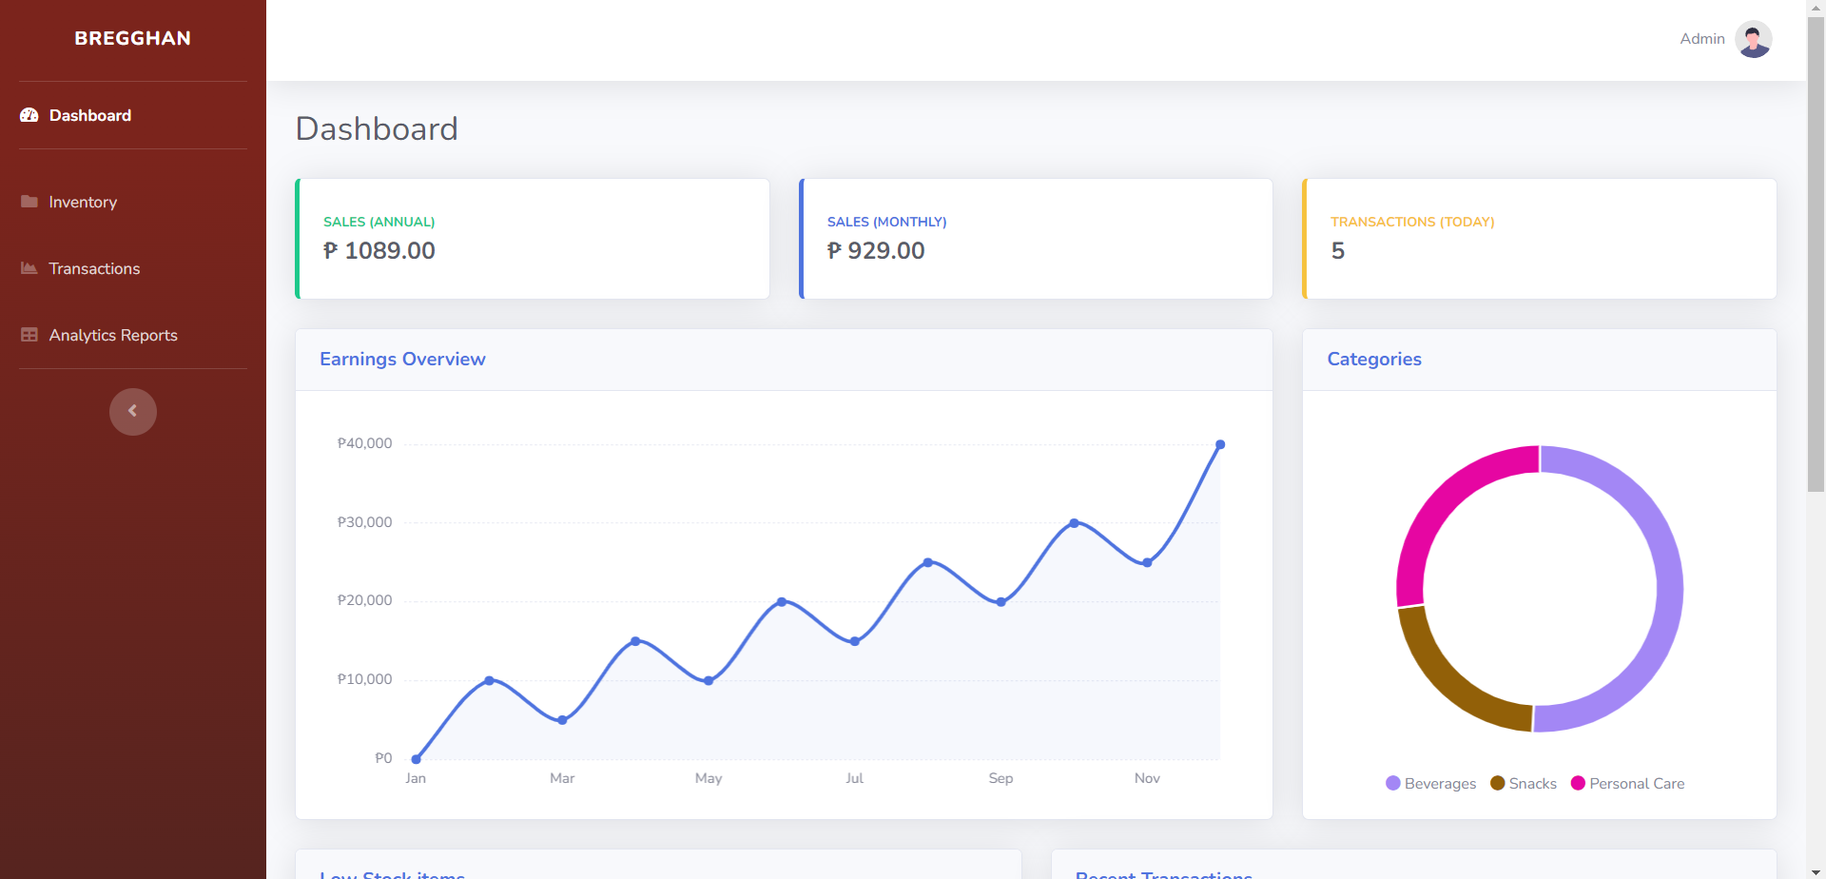

Figure 32 Home Screen

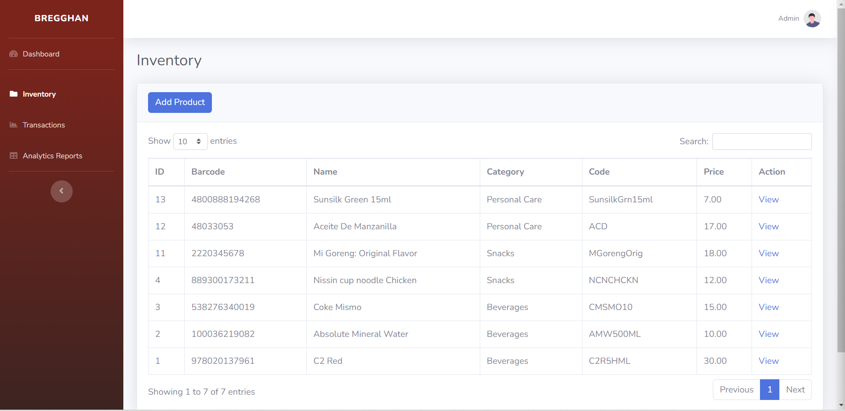

Figure 33 Inventory Screen

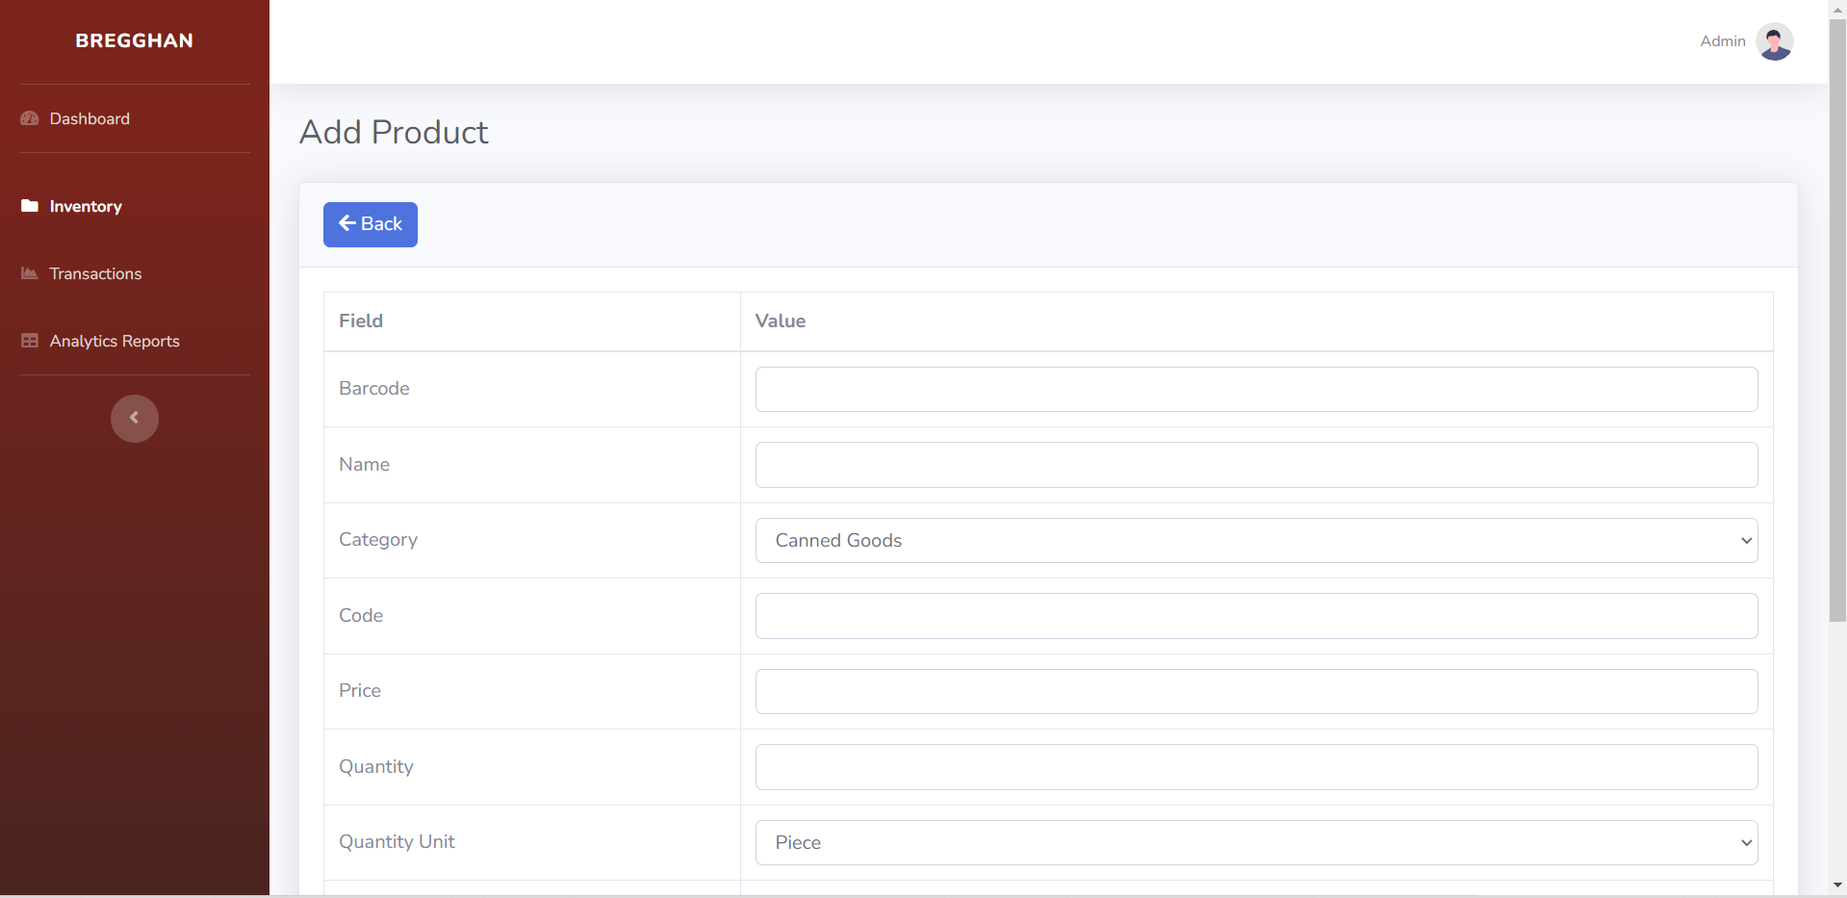

Figure 34 Add Item Screen

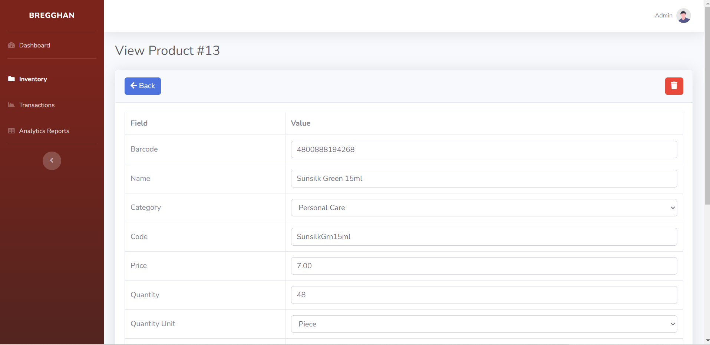

Figure 35 Edit Item Screen

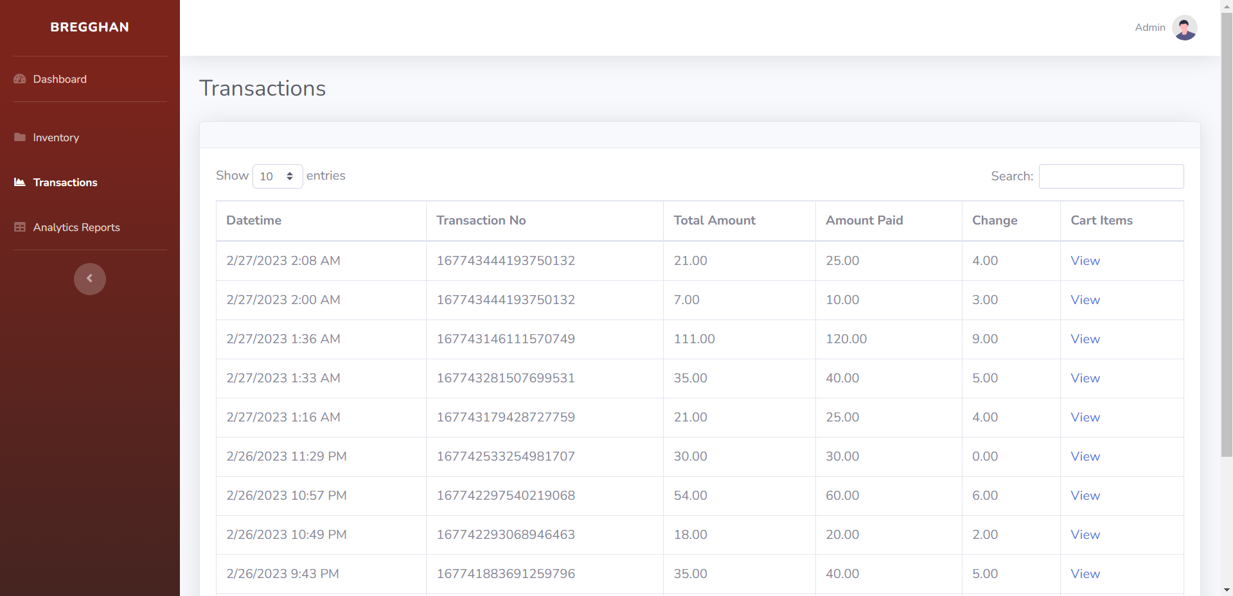

Figure 36 Sales Screen

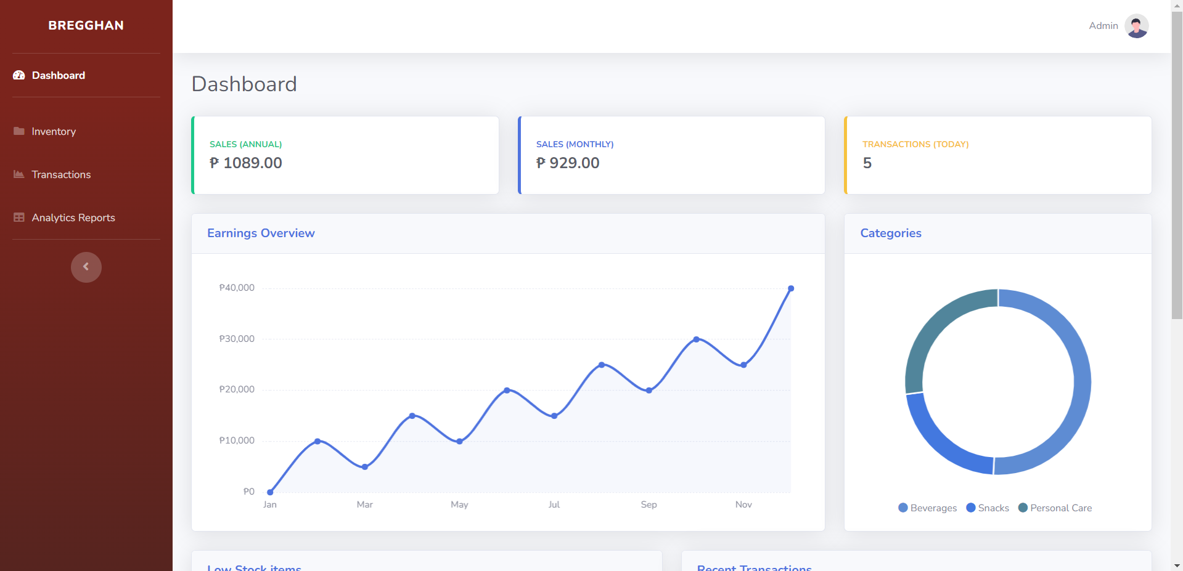

Figure 37 Analytics Report

## 5.3 Use Classes and Characteristics

Table XXXV User Classes and Characteristics

|  |  |
| --- | --- |
| Roles | Description |
| User/Store Owner | This user oversees tracking sales and inventory, resupplying of stocks, and managing the items/products catalog. |
| Staff | This user will oversee the customer transactions. This user will also be the one using the web application for the payment of the customer, which will generate a receipt. |

# Conclusion

The capstone project shows ways on how to solve the problem of Bregghan mini grocery store. Since the current system is outdated in the grocery itself which utilizes the use pen and paper to keep track of their stocks and as well as to create receipts for the customer. The developers aim to provide a web application that uses AWS DynamoDB and Vue JavaScript to create an POS-like web app that supports the grocery store. The client’s request was to create something that helps the stores to input new supplies and stocks and as well as to be able to keep track of their items sold and lastly to create a receipt for customers.

The project's completion should aid the client in terms of resolving and changing their current system with the integration of an automated computation of sales and monitoring of stocks. Furthermore, all the features of the web and mobile application is completed and all the features and the request of the client are met. Moreover, all the documents necessary for the completion of the project based learning is accomplished and are published within the developer's respective folder. Lastly, the developer's are responsible for guiding the client and its cashier for the utilization of the new system.

# References

|  |  |
| --- | --- |
| [1] | 15 May 2015. [Online]. Available: https://erply.com/pos-system/. |
| [2] | "Alicepos," 2 April 2020. [Online]. Available: https://alicepos.com/27-advantages-of-a-pos-system/. [Accessed 3 June 2022]. |
| [3] | "business news daily," 11 December 2017. [Online]. Available: https://www.businessnewsdaily.com/10449-time-saving-pos-reports.html. [Accessed 3 June 2022]. |
| [4] | S. Peek, "15 Top POS System Features," 21 September 2021. [Online]. Available: https://www.business.com/articles/features-of-pos-systems/. [Accessed 4 June 2022]. |
| [5] | A. Jain, "7 Key Features to Look for in a POS System," 30 January 2019. [Online]. Available: https://www.vinculumgroup.com/pos-system-key-features/. [Accessed 4 June 2022]. |
| [6] | S. Ahmad, "How a POS System Can Drive Your Customer Loyalty Program," 25 May 2022. [Online]. Available: https://blog.hubspot.com/service/pos-system-customer-loyalty-program. [Accessed 4 June 2022]. |
| [7] | 19 January 2022. [Online]. Available: https://www.logicerp.com/blog/2022/01/19/what-are-the-benefits-of-a-grocery-pos-system/. |
| [8] | "ehopper," [Online]. Available: https://ehopper.com/grocery-pos/. [Accessed 3 June 2022]. |
| [9] | "peddlr," 2021. [Online]. Available: https://peddlr.io/. [Accessed 2022 3 June]. |
| [10] | "shopify," 2020. [Online]. Available: https://www.shopify.com/pos. [Accessed 3 June 2022]. |

# Appendices

## Appendix A: Project Vision

Bregghan Admin System

For the owner of the mini grocery store to keep track of sales and inventory. In addition to the inventory, the owner will be notified when the inventory is running low. It will be easier for them to keep track of the goods, and there will be fewer chances of sales being lost due to early replenishment. The admin can also update the price and stock changes here.

Bregghan Cashier System

All the transactions will take place here. It will be linked to the database so that the administrator can keep track of the transactions. The cashier cannot change the pricing or edit the inventory but can only enter each transaction for the day.

## Appendix B: Product Roadmap

Table XXXVI Product Roadmap

|  |  |  |  |
| --- | --- | --- | --- |
|  | MNTSDEV | MYSADD1 | MCSPROJ |
| Admin Dashboard | * Low Fidelity wireframe of the webapp * Dashboard not yet accessible for Admin | * Early Deployment * Admin can access * Home Page * View Inventory Page | * Product Deployment * Sales Report * Analytics * Low Stock Notification * Manage Inventory |
| Cashier/Staff Dashboard | * Low Fidelity wireframe development of the webapp * Dashboard not yet accessible for Cashier/Staff | * Early Deployment * Cashier can access * Home Page | * Product Deployment * Point of Sale System |

## Appendix C: Team Meetings

AUGUST 25 Meeting for revisions from Client

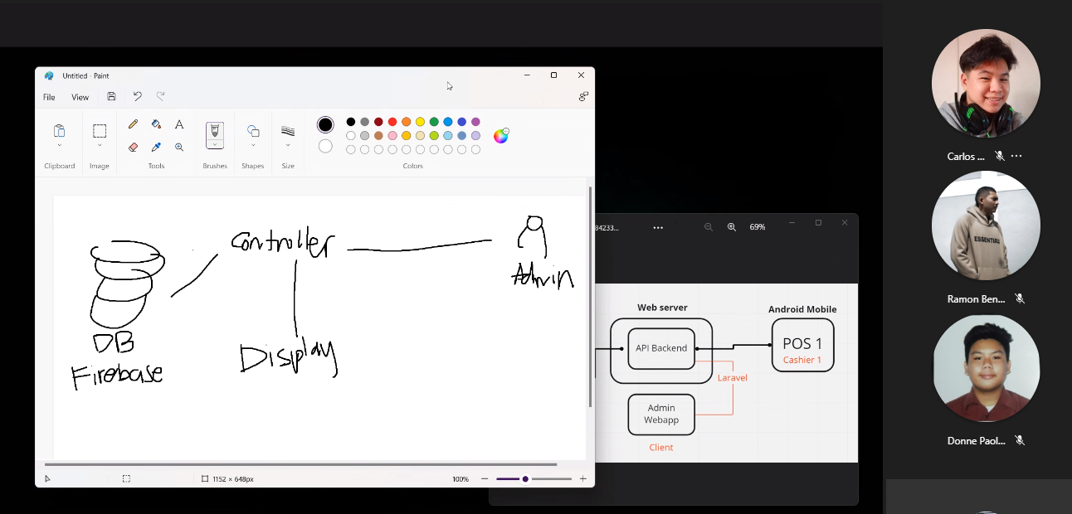

Figure 38 Meeting for Revisions from Client

AUGUST 30 Meet for Event table and Paper Revisions

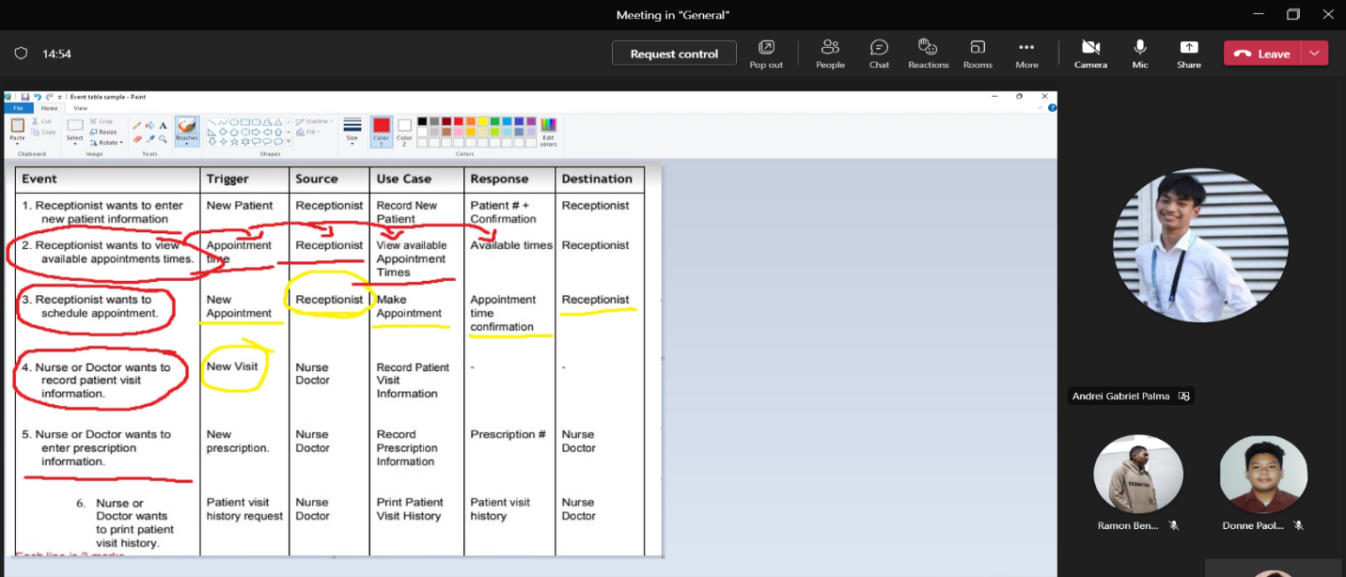

Figure 39 Meet for Event Table and Paper Revisions

September 7, 2022, Meet for CFD and DFD diagram

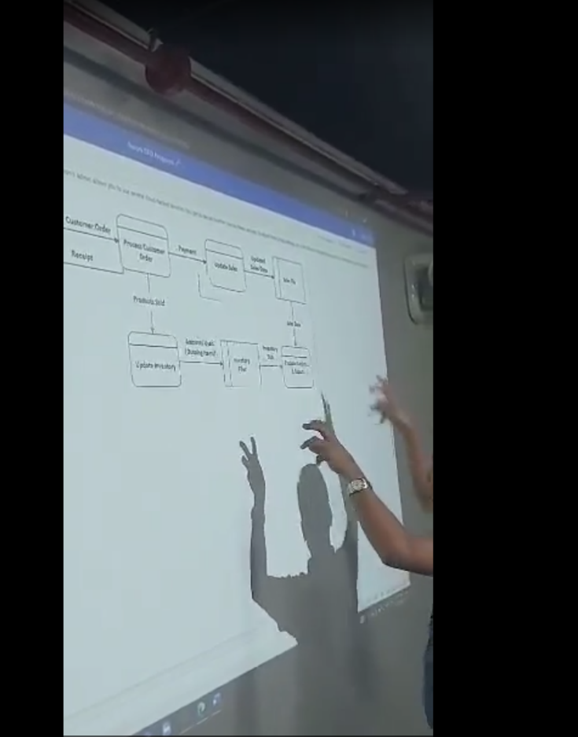

Figure 40 Meet for CFD and DFD diagram

September 14, 2022, Meeting for Updates of Diagrams

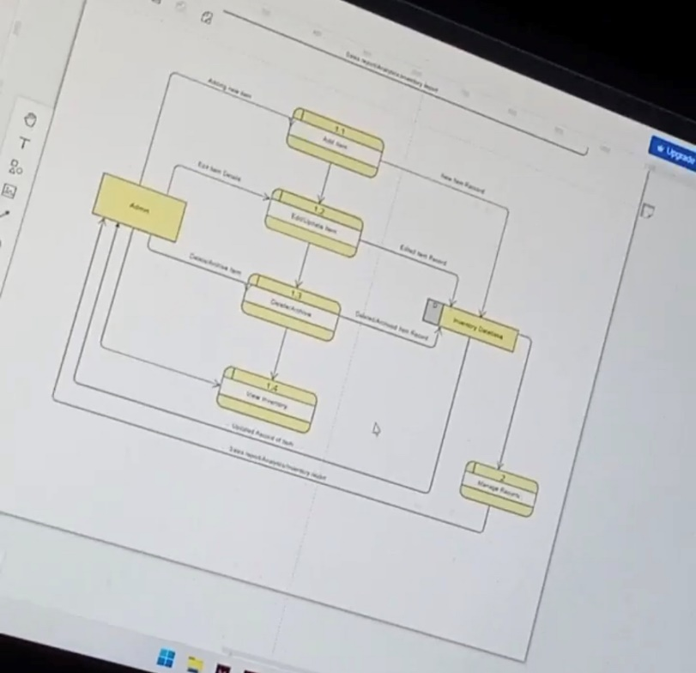

Figure 41 Meeting for updates of Diagrams

September 21, 2022, Meeting with Adviser

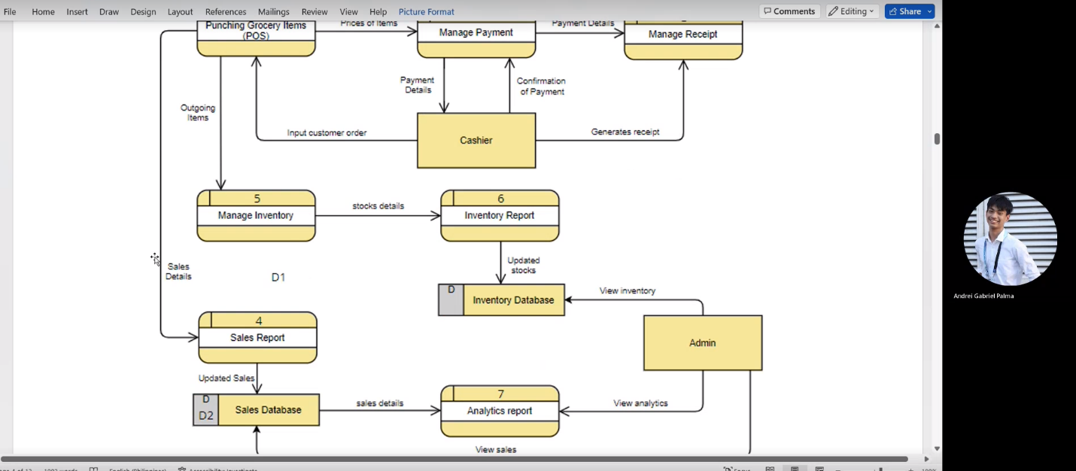

Figure 42 Meeting with adviser

## Appendix D: GitHub Repository Link

https://github.com/CarlosLigligen/Aurora_MCSPROJ

## Appendix E: GitHub Repository Link

https://github.com/CarlosLigligen/Aurora_MCSPROJ

## Appendix E: Minutes of the Meeting

**DATE:** 31/02/2023

**TIME:** 3:30 pm – 4:30 pm

**WHERE:** Asia Pacific College

**TYPE OF MEETING:** Decision Making

**FACCILITATOR:** Elloso, Ramon Benedict V.

**MINUTE TAKER:** Ligligen, Carlos Jr. C.

**PRESENT ATTENDEES**

|  |  |
| --- | --- |
| Ramon Benedict V. Elloso | **Student**  **Student**  **Adviser** |
| Carlos C. Ligligen Jr. |
| Doc. Manuel L. Calimlim Jr. |
|  |
|  |  |

**AGENDA TOPICS:**

* Paper update
* System update
* Comments Matrix

**ALLOCATED TIME:** 1 hour

**DISCUSSION:** Discussion with the updates of paper and system.

**CONCLUSION:** The team was able to improve the system and paper.

**DATE:** 08/02/2023

**TIME:** 10:30 pm – 11:00 pm

**WHERE:** Asia Pacific College

**TYPE OF MEETING:** Decision Making

**FACCILITATOR:** Elloso, Ramon Benedict V.

**MINUTE TAKER:** Ligligen, Carlos Jr. C.

**PRESENT ATTENDEES**

|  |  |
| --- | --- |
| Ramon Benedict V. Elloso | **Student**  **Student**  **Adviser** |
| Carlos C. Ligligen Jr. |
| Doc. Manuel L. Calimlim Jr. |
|  |
|  |  |

**AGENDA TOPICS:**

* Paper update
* System update
* Comments Matrix

**ALLOCATED TIME:** 30 Minutes

**DISCUSSION:** Discussion with the updates of paper and system.

**CONCLUSION:** The team was able to improve the system and final document.

**DATE:** 22/02/2023

**TIME:** 9:00 pm – 11:0 pm

**WHERE:** Asia Pacific College

**TYPE OF MEETING:** Decision Making

**FACCILITATOR:** Elloso, Ramon Benedict V.

**MINUTE TAKER:** Ligligen, Carlos Jr. C.

**PRESENT ATTENDEES**

|  |  |
| --- | --- |
| Ramon Benedict V. Elloso | **Student**  **Student**  **Student**  **Student**  **Adviser** |
| Carlos C. Ligligen Jr.  Andrei Gabriel B. Palma  Done Paolo Y. Tarinay |
| Doc. Manuel L. Calimlim Jr. |
|  |
|  |  |

**AGENDA TOPICS:**

* Paper update
* System demo with complete hardware

**ALLOCATED TIME:** 2 Hours

**DISCUSSION:** Discussion with the updates of paper and finished system.

**CONCLUSION:** The team was able to improve the paper and finish the system.

|  |  |  |
| --- | --- | --- |
|  |  | **Carlos C. Ligligen jr.**  **BS Information Technology** |
| **Profile**  I am an Information Technology student with dedication and passion for technology and desire to make a positive impact in the IT industry. I have gained a solid foundation in various technical skills such as programming languages, database management, web development, and software design. Additionally, I have honed my critical thinking, problem-solving, and communication skills through various academic and extracurricular activities. I am eager to embark on my professional career in the IT industry, where I can leverage my academic and practical experiences to contribute to the growth of an organization.  **Contact**  PHONE:  0950 491 4129  0976 030 5636  EMAIL:  ccligligen13@gmail.com |  | **EDUCATION**  **Benigno “Ninoy” Aquino High School (JHS)**  2014 – 2018  Technical Vocational Livelihood - Cookery  **AMA Computer College (SHS)**  2018 - 2020  Technical Vocational Livelihood – Information and Communications Technology  **Asia Pacific College**  2020 - Present  Bachelor of Science in Information Technology with specialization in Mobile and Internet Technology  **Certificates**   * Data Fundamentals – 2023 * Lifelong Learning – 2022 * Scrum Foundation Professional Certificate - SFPC™ - 2022 * Enterprise Design Thinking Practitioner – 2022 * Introduction to Packet Tracer - 2022   **work experiences**  **Work Immersion G12 – Pasig City General Hospital (2020)**   * Deployed at billing department. * Tasked with the preparation of patient’s individual statement of accounts. * Oversees mandated social legislation like coverages from Phil health, discounts for Senior Citizens, PWD and similar socialized benefits are applied in accordance with their respective implementing rules and regulations.   **Work Immersion G12 –** **MSI-ECS Complex, Pasig City (2020)**   * Deployed at customer service assistance department. * Tasked with basic troubleshooting and deals with scheduled appointments with a senior employee. |
|  |  | **Andrei gabriel b. palma**  **BS Information Technology** |
| **Profile**  I am an Information Technology student with the necessary skills that are honed with the knowledge that I gained in my college years. I have gained various technical skills such as basic troubleshooting of a computer, database management, web development, and software design. Furthermore, I have gained the necessary skills that enable me to communicate better with the teams since I am a highly motivated and dedicated student with strong communication and interpersonal skills, I am able to address certain issues that might arise among the team, and I have the capability to be flexible in work. I am also prepared to express my knowledge and skills in the IT industry wherein I can help to the expansion of the business.  **Contact**  PHONE:  09516613719  09668743393  EMAIL:  andreigabriel.palma@gmail.com |  | **EDUCATION**  **Asia Pacific College (SHS)**  2018 - 2020  STEM – Information Technology  **Asia Pacific College**  2020 - Present  Bachelor of Science in Information Technology with specialization in Mobile and Internet Technologies  **Certificates**   * Data Fundamentals – 2023 * Networking Essentials - 2022 * Lifelong Learning – 2022 * Scrum Foundation Professional Certificate - SFPC™ - 2022 * Enterprise Design Thinking Practitioner – 2022 * Introduction to Packet Tracer – 2022 * Happy D Workshop certificate - 2019 |
|  |  | **DONNE PAOLO Y. TARINAY**  **BS Information Technology** |
| **Profile**  I’m a student under the information technology track with knowledge and experience in the basics of the industry I possess more than necessary needs for the workplace to be an effective Information Technology Individual. In my years under the IT track, I have gained Skills that are necessary for the field like Programming languages, Web Design, Software and Hardware Development. I am Highly dedicated with my course as I am very much Familiar with today’s technological standards and will continue to prove further to contribute to achieve best results possible in future organizations and the industry. Lastly, I Have honed my communicating skills and critical thinking which are important parts in the IT industry to be an effective worker and to maximize the efficiency in the workplace.  **Contact**  PHONE:  0916 784 9992  865 03817  EMAIL:  Donnepaolotarinay@gmail.com |  | **EDUCATION**  **Bangkal High School**  2015 – 2018  **Asia Pacific College**  2018 - 2020  Information Technology  **Asia Pacific College**  2020 - Present  Bachelor of Science in Information Technology with specialization in Mobile and Internet Technology  **Certificates**   * Data Fundamentals – 2023 * Networking Essentials – 2022 * Lifelong Learning – 2022 * Scrum Foundation Professional Certificate - SFPC™ - 2022 * Introduction to Packet Tracer - 2022 |

|  |  |  |
| --- | --- | --- |
|  |  | **Ramon Benedict V. Elloso**  **BS Information Technology** |
| **Profile**  I am an Information Technology student with willingness to learn whatever it takes for the project to finish. Analyzing business needs filling the gap between business and technology. Also passionate about music and sports. He is a part of the school’s band organization and founded a flag football organization in the school.s  **Contact**  PHONE:  0926 697 4816  EMAIL:  bedictmann@gmail.com |  | **EDUCATION**  **St. Mary’s Academy Pasay City (Junior High School)**  2014 – 2018  **Asia Pacific College (Senior High School)**  2018 - 2020  Science, Technology, Engineering, and Mathematics strand.  (STEM)  **Asia Pacific College**  2020 - Present  Bachelor of Science in Information Technology with specialization in Mobile and Internet Technology  **Certificates**   * Data Fundamentals – 2023 * Agile Product Owner Role: Techniques - 2022 * Enterprise Design Thinking Practitioner – 2022 * Conducting SWOT Analysis – 2022 * UX Design 6: Paper Prototyping - 2021   **Organization**   * APC Band * Founder of Asia Pacific College Rams Flag Football Organization |